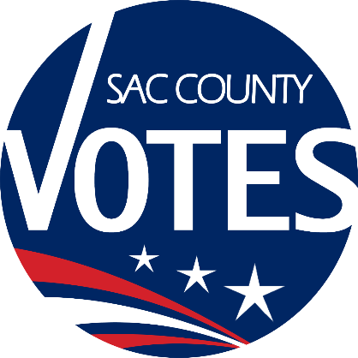

CO-CHAIRS
SHANNON
MEDINA-FOBBS
CJ MORRISON
SAM WINTERS
COLIN MCINNIS

Sacramento County
Voter Registration & Elections
Language Accessibility Advisory Committee

January 22, 2026 Meeting Agenda
1:00 PM

Location: Microsoft Teams
Join the meeting now
Meeting ID: 261 487 704 270 40
Passcode: kZ65oj9p

Dial in by phone
+1 916-245-8966,,617221565# United States, Sacramento
Phone conference ID: 617 221 565#

Agenda Items:
- Call to order and Introductions
- New Language Determinations
- Language Outreach
- Future Agenda Items
- The next LAAC meeting will be on April 23, 2026 at 1 p.m.
- Adjourn

Requests for documents in accessible formats, interpreting services, language assistance, assistive listening devices, or other accommodations should be made by calling the County Voter Registration and Elections Department at (916) 875-6451 or by emailing your request to LAACInfo@saccounty.gov.

