Red, white and blue circular logo that says Sac County Votes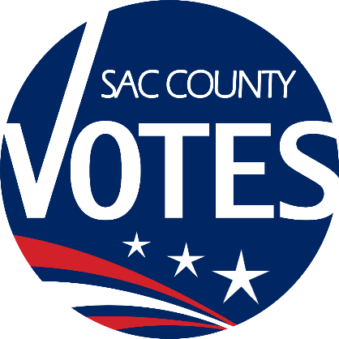

**CO-CHAIRS**

KAREN STARTUP

EMILY ELLIOTT

MIKE VANDERPOOL

JANNA FIORI

**Sacramento County**

**Voter Registration & Elections**

Voting Accessibility Advisory Committee

**July 24, 2025 Meeting Agenda**

**10:00 AM**

**Location: Microsoft Teams** [**Need help?**](https://aka.ms/JoinTeamsMeeting?omkt=en-US)

[**Join the meeting now**](https://teams.microsoft.com/l/meetup-join/19%3ameeting_YThhMGFkNzgtYjU1MS00ODBjLTk1YTctYzc5ZmQ0NDM0NTM2%40thread.v2/0?context=%7b%22Tid%22%3a%222b077431-a3b0-4b1c-bb77-f66a1132daa2%22%2c%22Oid%22%3a%2208504e86-68b0-4b11-b8e3-912f97788c07%22%7d)

Meeting ID: 240 229 056 610

Passcode: T9px9Jr3

**Dial in by phone**

[+1 916-245-8966,,490710765#](tel:+19162458966,,490710765)

United States, Sacramento

[Find a local number](https://dialin.teams.microsoft.com/e6ecf38a-c5f2-4b16-8b9b-b2e22c716ef8?id=490710765)

Phone conference ID: 490 710 765#

**Agenda Items:**

1. Welcome and introductions
2. Updates from State VAAC
3. Open Discussion
4. The next VAAC meeting will be on January 22, 2026 at 10 a.m.
5. Adjourn

Requests for documents in accessible formats, interpreting services, language assistance, assistive listening devices, or other accommodations should be made by calling the County Voter Registration and Elections Department at (916) 875-6512 or by emailing your request to [VAACInfo@saccounty.gov](mailto:LAACInfo@saccounty.gov), no later than 5 days prior to the meeting.