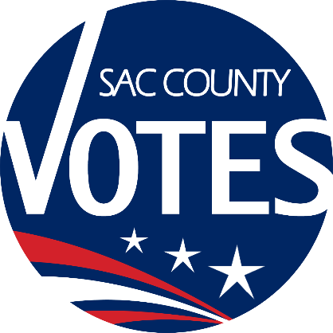

CO-CHAIRS
KAREN STARTUP
EMILY ELLIOTT
MIKE VANDERPOOL
JANNA FIORI

Sacramento County
Voter Registration & Elections
Voting Accessibility Advisory Committee

January 22, 2026 Meeting Agenda
10:00 a.m.

Location: Microsoft Teams
Microsoft Teams Need help?
Join the meeting now
Meeting ID: 254 529 891 820 70
Passcode: Lh3PM9Do

Dial in by phone
+1 916-245-8966,,994235725# United States, Sacramento
Find a local number
Phone conference ID: 994 235 725#

Agenda Items:
- Welcome and introductions
- VAAC-related Statewide Special Election debrief

- Updates from the State VAAC
- Open Discussion
- The next VAAC meeting will be on April 23, 2026 at 10 a.m.
- Adjourn
Requests for documents in accessible formats, interpreting services, language assistance, assistive listening devices, or other accommodations should be made by calling the County Voter Registration and Elections Department at (916) 875-6512 or by emailing your request to VAACInfo@saccounty.gov, no later than 5 days prior to the meeting.

