VOTE SAFE with Your Vote-By-Mail Ballot

All California voters will receive a vote-by-mail ballot for the November 3, 2020 election. Your county elections office will begin mailing ballots, similar to the one pictured below, beginning October 5, 2020.

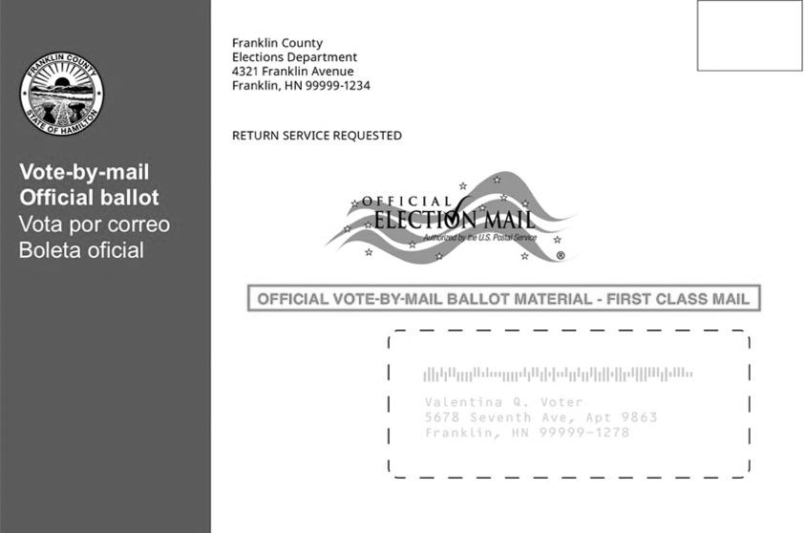

Voting by mail is SAFE and EASY.
After marking your choices on your ballot, simply:
Seal it.
Secure your ballot inside the envelope from your county elections office.
Sign it.
Make sure the signature on your ballot envelope matches the one on your CA driver license / state ID, or the one you provided when registering. Your county elections office will compare them to protect your vote.
Return it.
In person - Drop your ballot off at a secure drop box, polling place, or county elections office by 8pm on November 3, 2020.
By mail - Make sure your ballot is postmarked by November 3, 2020.
No stamp required!
OR
Track it.
You can sign up at wheresmyballot.sos.ca.gov for alerts by text (SMS), email, or voice call on the status of your vote-by-mail ballot.

Voters who can vote-by-mail will help ensure safe physical distancing at voting locations. Voting locations will be available in all counties before Election Day. Voting locations will offer voter registration, replacement ballots, accessible voting machines, and language assistance.

