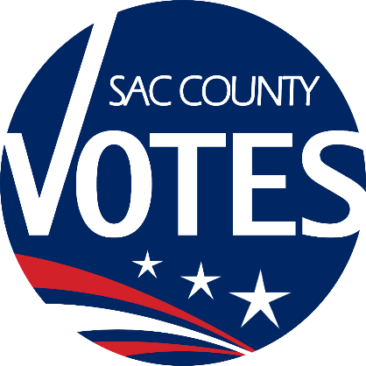

**CO-CHAIRS**

EMILY ELLIOTT

SHANNON MEDINA-FOBBS

MICHAEL

VANDERPOOL

**Sacramento County**

**Voter Registration & Elections**

Language Accessibility Advisory Committee

**January 23, 2025 Meeting Agenda**

**5:00 PM**

**Location: Microsoft Teams**

**Microsoft Teams** [**Need help?**](https://aka.ms/JoinTeamsMeeting?omkt=en-US)

[**Join the meeting now**](https://teams.microsoft.com/l/meetup-join/19%3ameeting_MTViODkxZGUtM2Y3Zi00ZWFkLWI3NmMtNzMyYThiYWNmMGE3%40thread.v2/0?context=%7b%22Tid%22%3a%222b077431-a3b0-4b1c-bb77-f66a1132daa2%22%2c%22Oid%22%3a%227a41e829-527b-4b72-beed-5055cb762579%22%7d)

**Meeting ID: 233 597 472 968**

**Passcode: 9Mr9gF3n**

**Dial in by phone**

[**+1 916-245-8966, 606886624#**](tel:+19162458966,,606886624) **United States, Sacramento**

[**Find a local number**](https://dialin.teams.microsoft.com/e6ecf38a-c5f2-4b16-8b9b-b2e22c716ef8?id=606886624)

**Phone conference ID: 606 886 624#**

**Agenda Items:**

1. Call to order and introductions
2. Updates from State LAAC
3. LAAC-related General Election debrief
4. LAAC recruitment
5. Language access materials/resources feedback
6. The next LAAC meeting will be on June 26th at 5 p.m.
7. Adjourn

Requests for documents in accessible formats, interpreting services, language assistance, assistive listening devices, or other accommodations should be made by calling the County Voter Registration and Elections Department at (916) 875-6512 or by emailing your request to [LAACInfo@saccounty.gov](mailto:LAACInfo@saccounty.gov)