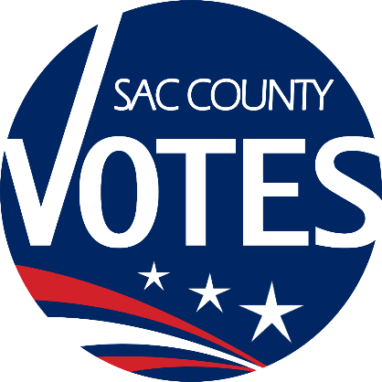

**CHAIR**

HANG NGUYEN

**CO-CHAIR**

THERESA RIVIERA

**SECRETARY**

BROOKE CROTZER

**MEMBERS**

EDGAR CALDERON

INDERJIT KALLIRAI

PALVINDER KAUR

HYOWAN KIM

CLARISSA LAGUARDIA

ELENA MORROW

EDSON PEREZ

ROBERTO RIZO

KOY SAETEURN

TERRY SCHANZ

**Sacramento County**

**Voter Registration & Elections**

Language Accessibility Advisory Committee

**July – December 2020 Meeting Schedule**

Location: For Social Distancing – Phone Meeting Only Until Further Notice

Meetings start at 12:00 PM and are 60-minutes long. Each meeting includes a review of the previous meeting’s notes and suggestions for future agenda topics. Topics may change based on input from committee members. Dial-in option is available and to be announced via email no later than five working days prior to the meeting.   
  **5. July 14th   
6. August 11th   
7. September 8th   
8. December 8th**This is an accessible facility. Requests for documents in accessible formats, interpreting services, assistive listening devices, or other accommodations should be made by calling the County Voter Registration and Elections Department at (916) 875-6512 or by emailing your request to voterinfo@saccounty.net, no later than five working days prior to the meeting.