FINAL

4-DAY VOTE CENTER LOCATION MAP
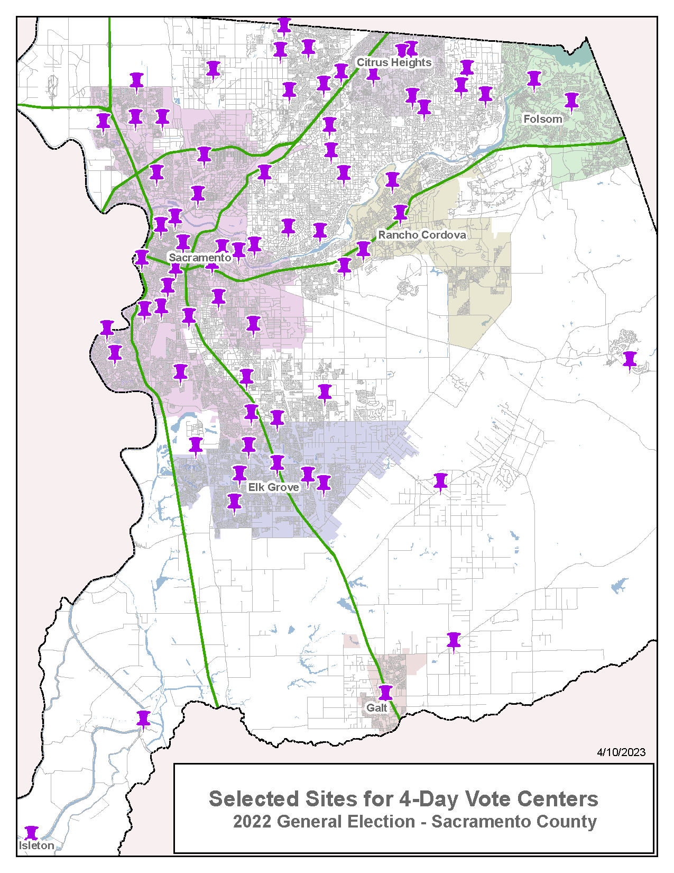

FINAL

11-DAY VOTE CENTER LOCATION MAP
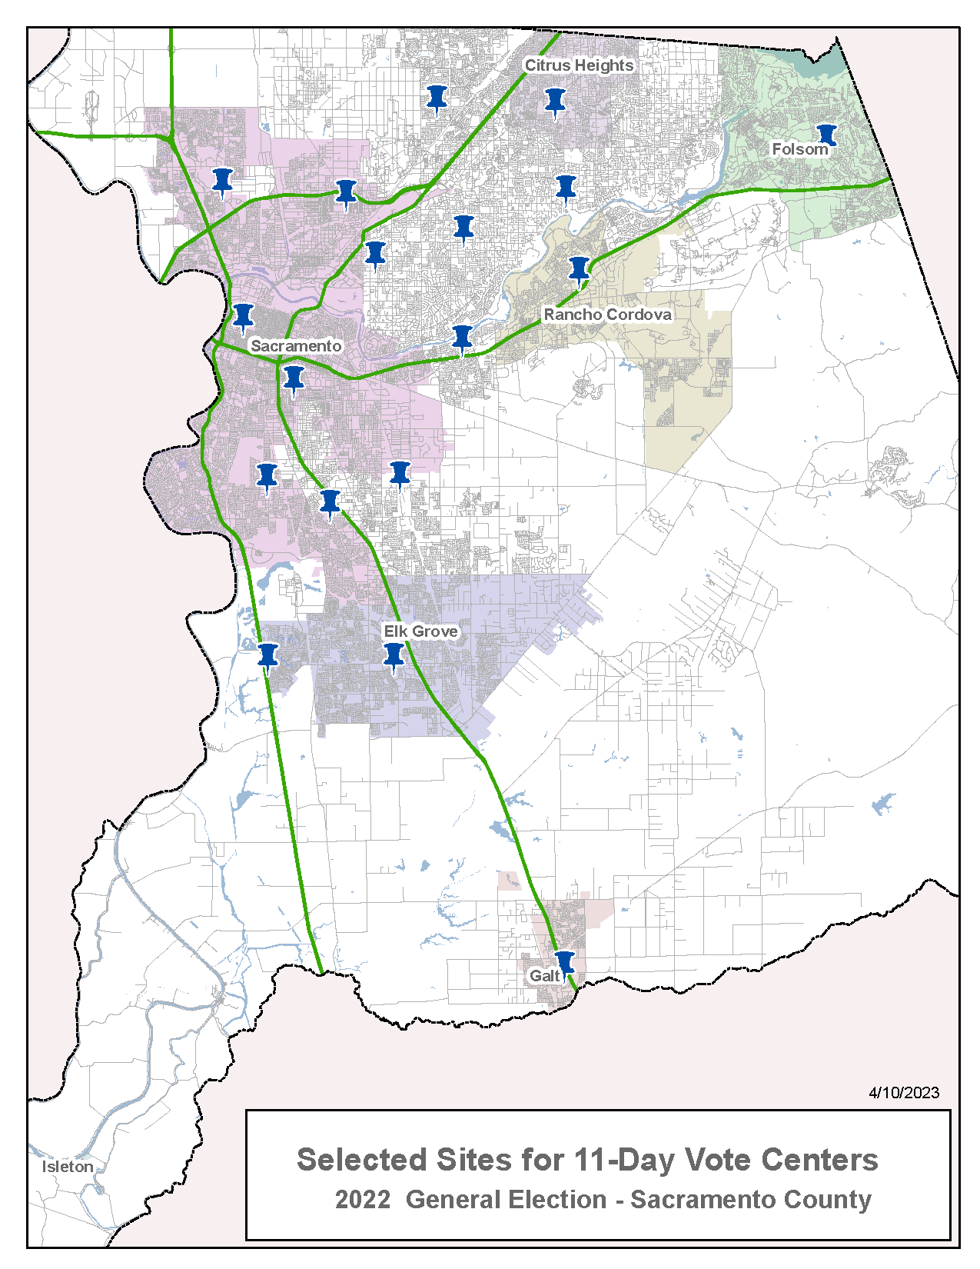

FINAL

DROP BOX SITES LOCATION MAP
