“SACRAMENTO” KAU DIH
GINV NYEI MIENH BIEQC MBUOX CAUX GINV NYEI JAUV-LOUC

GINV MIENH GORN ZAANGC NYEI ZA’EIX
COVID-19 FIENX-BOX

“Sacramento” Kau Dih
Ginv nyei Mienh Bieqc Mbuox & Ginv nyei Jauv-Louc
7000 65th Street, Suite A
Sacramento, CA 95823
(800) 762-8019
voterinfo@saccounty.net
www.elections.saccounty.net
Orn-Mbaih
I. GINV MIENH NYEI DORNGX DAUH 4
A. Mbenc Ziangx Tengx nyei Jauv 4
B. “PPE” Mbenc bun yiem norm-norm Ginv nyei Zaamc bun Yietc Zungv Gong-Mienh, ginv nyei mienh, caux samx mangc nyie mienh . 5
C. Zorng-mbaih & Zorng-mbenc: 5
D. Baaic fai Fangx Zeiv 7
E. Tiuv nyei Dorngx Dauh/Guon nyei Yietv-nyeic. 7
F. Ginv nyei Zaamc/Fungx Nzuonx Ginv nyei Sou-Daan. 7
II. GINV MIENH NYEI GONG-MIENH (SAAUV NYEI GONG-MIENH) 8
A. Lorz Mienh nyei Mienh. 8
B. Njaaux nyei Jauv. 8
C. Paaiv Jauv nyei Bieiv. 8
D. Buangh Zuqc Aqc nyei Jauv. 8
II. GINV MIENH DAAN DAPV FIENX FAANG & SIOU GINV MIENH NYEI SOU-DAAN 9
III. GINV NYEI MIENH FAAUX MBUOX & GINV NYEI DORNGX DAUH 9
A. Pouh Tong Zorng-Mbenc nyei Dorngx & Fioux Nzengc nyei Za’eix. 9
B. Ginv Mienh Daan nyei Yietv-nyeic. 10
C. Samx Mangc/Siou Gouv nyei Mienh. 10
IV. TONG FIENX BUN GANH DAUH & JIU TONG 11
A. Ginv yiem Fienx: Yietc zungv Ginv yiem Fienx nyei sou-gorn oix liemh jienv: 11
B. Maaih Mbienc nyei Ginv yiem Fienx (AVBM). 11
C. Ginv nyei Gorn nyei Yietv-nyeic . 11
D. Njiec Qaqv Jiu Tong caux Ganh Dauh 12
E. Ja’sic & Sou-horngh: 12
Sou-Jaa A – “CVIG” Baaic fai Fangx nyei Nyungc Zeiv 13
Sou-Jaa B – Zorng-Mbenc Ginv nyei Dorngx nyei Nyungc Zeiv 14
Sou-Jaa C – Fioux Nzengc Ginv nyei Dorngx nyei Yietv-nyeic 15
Sou-Jaa D – Ginv nyei Dorngx nyei Baaic nyei Nyungc Zeiv (MAIV GAENGH ZIANGX) 16
Sou-Jaa E – Mbenc Njaaux Ginv Mienh nyei Gong-Mienh Yiem nyei Dorngx Dauh 17
Sou-Jaa F – COVID Njaaux nyei Nyungc Zeiv 18
Sou-Jaa G – Bun-jaiv La’nyauv Sic nyei Za’eix 19
Sou-Jaa H – “VRE” Fioux Nzengc nyei Qorng Zeiv 20
Sou-Jaa I – Zorng-Mbaih Ginv Mienh nyei Yietv-nyeic 21

Jiex Gorn Waac:
Za’gengh longc jienv haic maiv oix bun ginv nyei mienh oix zuqc ginv taux simv baengc caux wangc siangx nyei jauv yiem Ziepc Yietv Hlaax 3, 2020 nyei Pouh Tong Ginv “President” nyei Hnoi. Dongh “corona” hieh baengc corc hiaangx jienv yiem mbuo nyei deic-bung, “Sacramento” Kau Dih gaanv jienv liuc leiz taux funx jienv caux maiv zuqc mbungh baengc nyei ginv mienh hnoi.
“Sacramento” Kau Dih Ginv Mienh Bieqc Mbuox & Ginv Mienh nyei Jauv (VRE) njiec lingc bun taux ziex cin dauh guaax hnyouv ginv mienh nyei gong-mienh. “Sacramento” Kau Dih nyei domh mouz deic se oix ei jienv Ginv Mienh nyei Leiz, ei jienv dingc daaih bun mienh Ginv nyei Dorngx Dauh 11 hnoi caux 4 hnoi hnangv yie mbuo duqv zoux jiex daaih yiem Faah Hlaax Ginv “President” nyei Hnoi-nyieqc. Maiv gunv hnangv naaic, yie mbuo setv mueiz mbenc daaih nyei dorngx dauh se ei maaih kungx nyei dorngx caux maaih mba’ziex laanh Ginv nyei Gong-Mienh.
“Sacramento” Kau Dih mbenc jienv oix zoux ei dingc daaih nyei leiz-nyeic ei Saengv nyei Sou-Biuv Gorn Zaangc nyei Yietv-nyeic yiem COVID-19 “Secretary of State’s Election Administration Guidance under COVID-19”
Yie mbuo nyei mouz deic se bun ginv mienh nyei mienh caux gong-mienh maaih maiv zuqc mbungc taux baengc nyei jauv yiem ninh mbuo zorng-mbenc naaiv kang longc jienv nyei jauv-louc bun taux horngc zaangc mienh. Naaiv deix za’eix oix biux mengh yie mbuo hnangv haaix nor zoux ziangx dingc daaih nyei mouz deic weic Ginv nyei Zaamc, Njaaux Ginv Mienh nyei Gong-Mienh, Fungx Fienx Faang, Ginv nyei Yietv-Nyei, Samx Mangc/Fiev Gouv Mienh, caux Tong Fienx/Jiu Tong nyei Jauv.

GINV MIENH NYEI DORNGX DAUH

Mbenc Ziangx Tengx nyei Jauv
    - Ganh Mingh Ginv a’fai Fungx Fienx “to-go”. Tengx nyei jauv yiem Ginv nyei Dorngx Dauh hnangv loz wuov nor. Ginv nyei mienh ganh haih mingh ginv a’fai mingh zorqv ginv mienh daan yiem dingc daaih Ginv Mienh nyei Dorngx Dauh. Cuotv liuz naaic, ginv nyei mienh, a’fai ganh dauh dingc daaih nyei mienh, dongh ginv nyei mienh duqv dau ziangx Borqv mingh, ginv nyei mienh, a’fai dingc daaih nyei mienh, yienx cuotv Ballot Pick-up Authorization form nyei sou-gorn bun ganh dauh tengx zorqv ginv mienh nyei sou-daan yiem naaiv norm zoux gong nyei dorngx 7000 65th Street, Ste A, a’fai haaix norm koi zoux gong nyei dorngx yaac duqv. Naaiv bun leiz ginv mienh nyei daan haih dorh nzuonx mingh bun ginv wuov laanh mienh dau ziangx. Yie mbuo bun nyei za’eix se dorh ginv mienh daan mingh dapv Ginv Mienh Faang a’fai Ginv nyei Dorngx.
    - Mbienc nyei Jauv. Jauv-hlen Ginv Mienh nyei Za’eix caux gauh camv jienv buo kang Mbienc Ginv Mienh nyei Ja’sic heuc (Dominion’s ImageCast X devices, a’fai “ICX”) oix borqv jienv mbenc bun yiem norm-norm Ginv Mienh nyei dorngx dauh.
    - Ginv Mienh Tengx nyei Jauv.
      - Nqenx Jauv nyei Hlaang oix mbenc daaih tengx dorh ginv nyei mienh bieqc cuotv bun taux m’zing maengh a’fai mangc maiv njang nyei mienh bieqc ginv nyei dorngx, “ICX” ja’sic, dieh, a’fai souv yiem zuov nyei ziangh hoc.
      - Buonh sin waaic fangx nyei mienh oix duqv zipv Gong-Mienh tengx nor tov mbuox bun hiuv dongh daaih taux nyei ziangh hoc.
      - Haih maaih duqv taux i laanh tengx nyei mienh dongh zanc bieqc. Maaih buang nzuih nyei ndie bun dauh dauh, liemh jienv fu’jueiv.
      - Se gorngv ginv nyei mienh maiv haih buang jienv nzuih nor, Gong-Mienh oix simv ninh 6 zaux go. Se gorngv ginv nyei mienh maiv buang fai buang maiv duqv nzuih mv baac qiemx zuqc Gong-Mienh tengx nor, Gong-Mienh oix zuqc dangh jienv buang hmien ja’sic weic simv baengc nyei jauv.
    - Ngaengc/Longc nyei Ja’sic.
      - Yienx cuotv zeiv-ngaengc taux Saengv Ginv Mienh nyei Yietv-nyeic caux zaah ndorqc nyei sou-fienx oix mbenc daaih an jienv Camv-Nyungc Waac nyei Dieh. Maiv daan naaic, yie mbuo oix zorng-mbenc baaic maaih jienv “QR codes” bun ginv nyei mienh haih zaah mangc taux ninh mbuo nyei Kau Dih Ginv Mienh nyei Yietv-nyeic a’fai Saengv Ginv Mienh nyei Sou-Fienx Yietv-nyeic yiem ninh mbuo nyei “smartphones.” Yie mbuo yaac oix kuinx ginv nyei mienh longc nyungc zeiv taux ginv mienh nyei sou-daan, dongh duqv mbenc ziangx yiem ninh mbuo nyei Kau Dih Sou-Fienx Yietv-nyeic, mbiuv ziangx ndaangc ninh mbuo mingh Ginv Mienh nyei Dorngx weic zanv ziangh hoc. (Doqc mangc Sou-Jaa A benx nyungc zeiv)
      - Gem Jienv nyei Fienx-Mbuoqc se maiv mbenc bun. Maiv gunv hnangv naaic, haaix laanh ginv nyei mienh qiemx zuqc lengc jeiv ziangh hoc gauh ndaauv nor, ninh oix zuqc nzipv ginv mienh nyei sou-daan benx ndaamv-buonc, yiem mbiuv ziangx nyei dorngx.
      - Ginv Mienh Longx Ciouv nyei Sou-Zaah maiv duqv mbenc bun yiem ih hnyangx ginv nyei jauv. Mv baac, maaih heuc dinc bieqc nyei mbatv oix mbenc bun taux maaih waac-naaic, nzauh heix nyei jauv, waac-zorc, a’fai zaah dimv taux ginv nyei sou-daan.
      - Dongh “VRE” oix mbenc yienx cuotv nyei ginv mienh zeiv-ngaengc bun, tov koi doqc mangc yie mbuo Ginv Mienh Faan Waac nyei Sou-Guv, haih yienx cuotv bun duqv nyei se gorngv meih tov naaic lorz yiem “Check-in Officer” nyei Gong-Mienh.

“PPE” paaiv norm-norm Ginv Mienh nyei Dorngx maaih Gong-Mienh, ginv nyei mienh, caux samx nyei mienh.
    - Gorqc zeic beu jienv buang nzuih nye ndie, liemh jienv fu’jueiv nyei
      - Kuinx ginv nyei mienh oix zuqc buang jienv nzuih mv baac maiv heuc nzuonx se gorngv maiv buang nor.
      - Buang nzuih ndie mbenc ziangx bun maiv maaih nyei mienh.
      - Maaih ziangx yietv-nyeic bun Gong-Mienh hnangv haaix liuc leiz taux (Doqc mangc (II)(D) naaiv deix La’nyauv nyei Jauv-Louc).
    - Longc liuz guangc nyei buoz-matc, mbenc ziangx yiem norm-norm Ginv Mienh nyei zaamc
      - Tiuv siang bun dauh dauh ginv nyei mienh caux jiu tong liuz
      - Se gorngv maiv maaih buoz-matc nor, maaih nzaaux buoz ndie bun dauh dauh ginv mienh nyei mienh
    - Longc yietc nzunc nyei batv
    - Nzaaux buoz ndie, yiem norm-norm Ginv Mienh nyei Dorngx caux yiem yietc zungv Gong-Mienh zoux gong dorngx, tengx fioux nzengc yiem bieqc gaengh nyei ziangh hoc
    - Buang Hmien Ja’sic, maaih nyei se gorngv qiemx zuqc nor, oix mbenc bun benx ganh diuc za’eix bun dongh maiv laengz dangh buang nzuih ndie nyei mienh
    - Nqenx Mienh nyei Yaang
    - “MG” Ndie 70% “Isopropyl Alcohol” nzaaux buoz ndie longc doc gaeng:
      - “ICX” nyei jaqv, nzunc-nzunc longc liuz
      - “ICX” Koi Longc nyei Zeiv-ngaengc
      - Ginv nyei dieh, nzunc-nzunc longc liuz
      - Gong-Mienh longc nyei “laptops, printers, DYMO Labelers, USB ja’sic, liemh jienv “Mobile Ballot Printer” fonh yienx Ginv Mienh nyei Zorngh
      - Ginv Mienh nyei Mbuoqc, nzunc-nzunc longc liuz
      - Nqenx nyei Zeiv-Yaang: se gorngv hluo liuz, ciuv an, hnopv mbiaapv zuqc, a’fai ginv nyei mienh maiv buang nzuih
      - Nqenx Jauv Hlaang
      - Dieh, Eiv, nzunc-nzunc longc liuz
      - Dongc fai ndiouh
Simv Baengc Sou-Daan (MSDS) oix mbenc daaih an norm-norm Ginv nyei Zaamc taux hnangv haaix nor tengx gong-mienh, se gorngv ninh mbuo ca’bouc longc zuqc haih hoic mienh nye ndie.

Qorng Zeiv & Zorng-Mbenc:
    - Maaih baaic box taux wuov norm qongx kungx haih bieqc duqv mba’ziex laanh ginv nyei mienh naetv jienv yiem norm-norm Ginv nyei Dorngx. Naaiv liemh jienv ginv nyei mienh, samx mangc nyei mienh, caux Gong-Mienh. Dingc longc nyei za’eix taux mienh laanh se yietc laanh mienh yiem 100 zaux biei-bung ndorqc. Gong-Mienh, benx Tengx nyei Mienh, oix souv jienv ga’nyiec nitv fatv Ginv Mienh nyei Dorngx caux maaih gong-bou hnangv naaiv:
      - Zaah dimv taux haih bieqc duqv ndongc haaix camv nyei mienh (maaih gorngv waac zorngh gan sin yiem jangv nyei dorngx)
      - Zipv Ginv Mienh Sou-Daan yiem dapv fienx dorngx bun ginv nyei mienh. Ginv mienh nyei sou-daan maiv zipv yiem ginv nyei dorngx, cuotv liuz ninh mbuo maaih dingc daaih tengx nyei jauv. Zung-nyiouh oix mbenc ziangx yiem yietc zungv Ginv Mienh nyei Dorngx longc guon ninh mbuo nyei fienx-mbuoqc.
      - Bun beu jienv buang nzuih ndie dauh dauh maiv maaih nyei mienh, liemh jienv fu’jueiv a’fai ganh dauh tengx nyei mienh.
      - Samx Mangc Mienh. Samx nyei Mienh, Dimv nyei Mienh, Div Zuangx Mienh maiv haih bieqc gu’nyuoz ginv nyei dorngx se gorngv maiv buang hmien nor. Naaiv se benx leiz!
      - Ginv nyei Dorngx Dauh maiv maaih buang nzie yiem ga’nyiec maengx nor oix zuqc duqv torngv duqv wuom nyei ndopv-liuh.
    - Ginv nyei dorngx maaih gauh camv jiex yietc dauh gaengh, dongh mbiuv jienv nqaengc nyei “Bieqc” caux “Cuotv” nyei dorngx oix an nqaengc nyei. Dongh kungx maaih nduqc dauh bieqc/cuotv nyei gaengh, Tengx nyei Gong-Mienh zaah dimv taux mienh bieqc gaengh camv caux zoqc nyei jauv.
    - Norm-norm Ginv nyei Dorngx maaih qorng zeiv taux zorng-mbenc nyei jauv liemh jienv haih bieqc duqv mienh ndongc haaix camv caux yiem nyei dorngx weic zoux ei laanh simv laanh nyei leiz (Doqc mangc Sou-Jaa B benx nyungc zeiv)
    - Nzaatv setv nzeiv-nyiouz mbuov nyei biux mengh ginv nyei mienh oix zuqc souv nyei dorngx dongh zuov jienv bieqc mbuox nyei ziangh hoc, zuov ginv sou-daan a’fai “ICX” nyei zorngh. Naaiv deix mbiuv nyei jauv oix zuqc mbenc ndaangc ginv nyei hnoi yiem Ginv nyei Gong-Mienh (ga’nyiec maengx) caux yie mbuo nyei “Chaser” zunc mienh nyei guanh fungx ga’naaiv longc bieqc cuotv (gu’nyuoz maengx).
    - Nqenx-ndiouh oix mbenc ziangx bun domh ginv nyei dorngx dauh corng jienv hlaang yiem gu’nyuoz caux ga’nyiec Ginv Mienh nyei Dorngx.
    - Zeiv-yaang-nqenx oix mbenc ziangx yiem Faaux Mbuox nyei Dorngx, Ginv nyei Dorngx, caux “CVR” Zoux Gong Dorngx. Maaih mbungh jienv longx nyei ja’sic ei qiemx longc nyei dorngx.
    - Maaih mbungh jienv nyei eiv bun longc yiem wuov norm dorngx dauh a’fai bun cuotv yiem “VRE” se gorngv wuov norm dorngx maiv maaih gaux 20 norm jaa nyei eiv. Naaiv deix eiv oix zuqc dingc ziangx bun baeng douh zuov ginv nyei mienh.
    - Dingc ziangx Fioux Nzengc dorngx “Sanitation Station” (Mangc yiem Sou-Jaa A benx “S”) oix mbenc ziangx maaih zoux buoz nzengc ndie caux faev mbiutc zeiv.
    - Norm-norm dorngx oix maaih la’lapv-mbuoqc siou la’fapv, longc jiex nyei buang nzuih ndie, longc jiex nyei buoz-matc, longc jiex nyei batv, ganh nyungc.
    - Kungx longc yietc nzunc nyei batv oix mbenc bun ginv nyei mienh yiem Ginv Mienh nyei Dorngx a’fai “CVR” Zoux Gong Dorngx. Mbenc ziangx batv yiem Faaux Mbuox dorngx, caux jienv fiev nzangc zeiv, weic jiu tong maiv mbienc nyei jauv.
    - Fioux nzengc nyei yietv-nyeic oix mbenc bun yiem norm-norm Ginv nyei Dorngx yiem Ginv Mienh Gorn Yietv-Nyeic Sou-Gapv (Mangc yiem Sou-Jaa C benx nyungc zeiv). Gong-Mienh oix zuqc fioux nzengc ganh nyei dorngx ndorm-ndorm, caux lungh muonz se gorngv ga’nyeic-hnoi maiv daaux nqaang aqv. Tengx nyei Gong-Mienh oix maaih zuqc liuc leiz fioux nzengc caux zaah dimv longc nyei dorngx caux “ICX” jaqv.
    - Ndo nyei nzaaux nzengc, liemh jienv yietc zungv ngaengc nyei dieh, ga’ndiev ndau, hluo nyei dorngx, “HEPA” nyei ga’naaiv-louc, oix mbenc bun yiem norm-norm Ginv Mienh nyei Dorngx.

  - Baaic – Sou-Jaa D Nyungc Zeiv
    - “Yie Mbuo Tov Meih Buang Jienv Nzuih”, buo nyungc waac, yiem gu’nyuoz caux ga’nyiec norm-norm Ginv nyei Dorngx
    - Bieqc Maengx/Cuotv Maengx nyei Mbiuv, buo nyungc waac
    - Samx nyei Mienh/Ginv Zaah nyei mbiuv, Meiv Guoqv nzangc hnangv
    - “Sacramento” Kau Dih Bieqc Duqv Mba’ziex Laanh Mienh nyei baaic, “Sacramento” Kau Dih sa’eix mienh longc jienv nyei, buo nyungc waac
    - “Baeng Douh Yiem Naaiv” nyei baaic
    - Waac-saauv, naetv jienv yiem ginv nyei dorngx
    - Fioux Nzengc Dorngx Dauh nyei Baaic

  - Tiuv Dorngx Dauh/Guon nyei Yietv-nyeic. Maaih tiuv nyei jauv yiem nqa’haav dingc ziangx yiem Kau Dih Ginv Mienh Sou-Fienx nyei Sou-Guv, Ginv Mienh nyei Dorngx maaih maiv haih koi, weic dorngx dauh fai Gong-Mienh maiv gaux. Se gorngv naaiv kang jauv benx cuotv nor, “Sacramento” Kau Dih oix hnangv naaiv nor zoux:
    - Maaih nzangc hlo nyei fiev yiem kuaaiv benv biux mengh taux ganh norm koi jienv Ginv Mienh nyei Dorngx maaih jienv dorngx yiem caux ndau-beih fangx nitv fatv meih yiem nyei dorngx.
    - Dingc yietc guanh 2 laanh mienh mingh souv jienv yiem guon nyei dorngx maaih jienv siqv-lunx Ginv Mienh yiem Fienx nyei mbuoqc siou kungx fungx nzuonx ginv mienh nyei sou-daan.
    - Zorc “website”, ginv mienh nyei ja’sic, “SacVote” nyei “app”, caux box mbuox tong fienx yiem dienx nyei jauv bun mienh camv hiuv.
    - Bun yietc zungv div zuangx yiem “VRE” duqv hiuv taux tiuv nyei jauv.

  - Ginv nyei Dorngx/Ginv nyei Sou-Daan Daaux Nqaang Nzuonx. Ginv nyei gong-mienh caux dingc daaih fungx Ginv Fungx Sou-Daan nyei mienh oix dangh jienv buoz-matc. Gong-mienh yiem “VRE” oix dangh siang-buoz-matc yiem dimv ganh norm fungx daaih nyei ginv mienh daan a’fai Ginv Mienh nyei Gorn. Tor Ginv Sou-Daan nyei cie a’fai gaav daaih nyei cie yaac oix zuqc ei jienv fioux nzengc nyei yietv-nyeic fioux nzengc ndaangc ninh mbuo dingh gong.

GINV NYEI GONG-MIENH (SAAUV NYEI GONG-MIENH)
  - Lorz Mienh nyei Mienh. Yiem Cietv Hlaax 2020, mbenc ziangx nyei mbatv oix fungx cuotv bun gauh camv 10,000 Ginv Mienh nyei Dorngx dongh “Sacramento” Kau Dih maaih nyei daan. Ginv nyei Gong-Mienh haih zoux ziangx caux fungx nzuonx zeiv-ngaengc, maiv zuqc bun fungx fienx nzuonx nyei zinh, a’fai bieqc “online” mingh dingc kungx nyei hnoi-nyieqc weic Ziepc Yietv Hlaax 3, 2020 Ginv nyei Jauv. Cuotv liuz naaic, maaih fiev njiec waac-zaah nyei dorngx bun taux guaax hnyouv nyei “PPE” tengx nyei jauv. Ei yie mbuo haih zoux duqv longx jiex nyei banh zeic, yie mbuo oix mbenc maaih njaaux taux “souv mangc” nyei Gong-Mienh dongh mingh tengx maaih mienh camv nyei dorngx a’fai bieqc daaih benx div nyei mienh.

  - Njaaux. Gauh camv njaaux nyei sou-horngh oix mbenc ziangx yiem Hungh Heic Ginv Mienh fai “Election Officer EasyVote” nyei gorn dongh mbenc ziangx benx “PowerPoint” sou-fangx caux siou benx waac caux fangx-nangh. Oix zuqc maaih gaux zoqc jiez nyei soux mouc bun buangh hmien hoqc nyei mienh cingx haih koi hoqc yiem “VRE” nyei zoux gong dorngx yiem 7000 65th Street. Naaiv kang njaaux nyei jauv se njaaux jienv mingh liuz hoqc zoux jienv mingh dongh maaih faaux jienv mbuox longc “laptops”, “Mobile Ballot Printers” benx yienc cuotv ginv mienh nyei sou-daan, caux “ICX” nyei Ja’sic. Yietc dauh horqc saeng duqv zipv gorqc zeic nyei ja’sic dongh maaih zoqc jiex nyei soux mouc bun gong-mienh bieqc yiem yietc kang kauv hoqc nyei jauv. Sou-Jaa E gorngv muonc taux yie mbuo “njiec buoz-zaux hoqc” nyei jauv. Yietc zungv Ginv Mienh nyei Gong-Mienh oix zuqc buang jienv nzuih yiem hoqc nyei qangx caux yiem Ginv nyei Dorngx Dauh.

Cuotv liuz naaic, Ginv nyei Gong-Mienh dongh duqv ei jienv COVID-19
“Sacramento County Department of Personnel Services” gorn zaangc nyei leiz njaaux liuz wuov deix oix mbenc bun (Sou-Jaa F). Zaah Dimv nyei Mienh yaac oix zuqc ei jienv doqc mangc fioux nzengc nyei yietv-nyeic caux dorngx dauh fioux sung nyei jauv-louc caux ei dingc ziangx nyei Gong-Mienh. Ginv nyei Gong-Mienh oix njiec ninh mbuo nyei mbuox yiem gong-zinh nyei daan biux mengh ninh mbuo duqv zipv hoqc hiuv nyei jauv mi’aqc.

  - Paaiv Jauv nyei Bieiv. Mbenc Tengx nyei Mienh oix mingh tengx yiem norm-norm Ginv nyei Dorngx. Naaiv deix Tengx nyei Gong-Mienh oix yiem ga’nyiec Ginv Mienh nyei dorngx maaih jienv siqv-lunx mbuoqc zipv ginv mienh nyei sou-daan dongh mbenc ziangx fungx nzuonx wuov deix. Cuotv liuz naaic, naaiv deix Tengx nyei Mienh oix zaah mangc taux maaih mba’ziex mienh yiem gu’nyuoz maengx caux mbenc buang nzuih ndie bun dongh maiv maaih wuov deix. Naaiv deix Tengx nyei Gong-Mienh oix dangh jienv siqv-lunx kuangx jaang ndiux mbuox nyei hlaang biux mengh ninh mbuo benx Ginv Mienh nyei Gong-Mienh. Tengx nyei Gong-Mienh oix borqv hoqc jienv mingh taux dimv mangc njiec mbuox taux fungx nzuonx nyei fienx-mbuoqc caux maaih zung-nyiouh bun ginv nyei mienh. Buoz-matc caux zoux buoz nzengc nye indie oix mbenc bun yietc zungv caux Tengx nyei Gong-Mienh oix zuqc zanc-zanc dangh jienv buoz-matc dongh muoqv taux ginv mienh nyei sou-daan a’fai ganh dauh nyei haaix nyungc ga’naaiv-longc.

  - Buangh Zuqc Aqc nyei Jauv. Pouh Tong Ginv “President” nyei Jauv-Louc se benx aqc caux la’nyauv haic. Yiem jienv butv hieh baengc nyei qangx, naaiv deix jauv-louc oix jaa gauh hniev caux doix-dekc taux longc buang nzuih nyei jauv, zaangv ginv mienh nyei leiz, caux baeng douh ndaauv nyei jauv zungv oix maaih camv faaux. Cuotv liuz ginv nyei mienh tong fienx caux mauv oix buatc nyei jauv taux baeng douh ndaauv yiem Ginv nyei Hnoi, yie mbuo mbenc jienv tengx Ginv nyei Gong-Mienh taux za’eix hnangv haaix nor yiem horpc caux simv cuotv la’nyauv nyei sic. “Sacramento” Kau Dih oix dorh Saengv nyei Sou-Biuv mbenc daaih nyei Yietv-Nyeic daaih longc dongh mbenc yiem Ginv Mienh nyei Sou-Guv Sou-Gapc taux hnangv haaix nor liuc leiz la’nyauv sic (Sou-Jaa G).

Cuotv liuz naaic, yietc zungv Ginv nyei Dorngx Dauh oix box bun Goux Sic nyei Kau Dih hungh jaa, “Sheriff” caux Mungv Goux Gorn “City Police Department” mbungh taux naaiv deix sic haih benx cuotv. Goux Sic Mienh “Police” a’fai “Sheriff” duqv zipv heuc yiem maaih sic daaih liuz Ginv nyei Gong-Mienh maiv haih gunv maiv njiec nyei ziangh hoc.

- GINV MIENH DAAN DAPV FIENX FAANG & SIOU GINV MIENH NYEI SOU-DAAN. “Sacramento” Kau Dih jiu tong caux camv-norm hei caux maaic ga’naaiv nyei poux taux qiemx longc nyei ja’sic taux fungx fienx faang yiem Kau Dih gu’nyuoz. “Raley’s/Bel-Air” nyei domh hei laengz tengx bun dorngx zipv Fungx Ginv Mienh Nzuonx nyei Faang caux “VRE” oix mbenc yiem camv-norm dorngx yiem “Sacramento” Kau Dih. “VRE” oix borqv jienv jiu tong caux “Sacramento” Sou-Lamz taux mbenc zipv Fungx Fienx Nzuonx nyei Faang caux yie mbuo nyei Mungv Zaangc Zoux Gong nyei Dorngx. Yie mbuo nyei mouz deic se oix maaih 58 norm Zipv Ginv Mienh Zipv Fienx Faang nyei dorngx dauh jiex gorn koi yiem Ziepc Hlaax saengh 5. Maaih I norm an ga’nyiec maengx nyei faang oix mbenc yiem “VRE” caux yiem “Citrus Heights City Hall.”

Dingc ziangx nyei dorngx dauh oix box yiem “VRE” nyei “website” yiem Juov Hlaax ndaamv, caux oix juangc jienv Kau Dih Ginv Sou-Fienx nyei Yietv-Nyeic caux Ginv nyei Mienh fungx benx Fienx nzuonx nyei sou-horngh.
Ih zanc maaih fih nzaeng nyei jauv taux Meiv Guoqv Fungx Fienx Gorn, “VRE” borqv jienv jiu tong caux buonh deic fungx fienx nyei div zuangx mienh. Maiv gunv haaix nyungc jauv benx cuotv Ziepc Yietv Hlaax fatv jienv daaih, nzauh heix nyei jauv zungv hiaangx buangv deic bung mi’aqc. “VRE” oix jaa dorngx dauh bun maaih zipv ginv mienh nyei sou-daan nzuonx yiem camv-norm dorngx. Maaih camv-guanh mienh oix zanc-zanc zaah dimv taux naaiv deix faang caux siou fungx nzuonx nyei sou-daan ei jienv Jiepv Sih Ginv Mienh Sou-Daan nyei Yietv-nyeic Emergency Ballot Pick-up standards.
Yie mbuo tov horngc zaangc nyei mienh tengx “VRE” siou nzuonx ginv nyei sou-daan, se gorngv “VRE” zoux maiv hingh fungx nzuonx nyei sou-daan nor. Juangc gong zoux nyei horngc zaangc mienh haih duqv zipv borng-mbieiv nyei leiz tengx siou ginv mienh nyei sou-daan div “VRE”, hnangv Ginv Mienh nyei Zipv Fienx Faang nyei yietv-nyeic nor. Naaiv deix Div Zuangx nyei sou-gorn caux yietv-nyeic yaac mbenc ziangx bun laangz zaangc kungx-tengx nyei mienh longc tengx yiem kang-kang jauv. Nqoi nzuih taux siou ginv mienh nyei daan se ei Ginv Mienh nyei Sou-Biuv dingc caux oix zuqc ei jienv leiz-nyeic caux yietv-nyeic zoux.

GINV NYEI MIENH FAAUX MBUOX & GINV NYEI DORNGX DAUH
  - Pouh Tong Zorng-Mbenc nyei Dorngx & Fioux Nzengc nyei Za’eix.
Bieqc Feix Hlaax caux Hmz Hlaax, “VRE” duqv jiex gorn zorng-mbenc yiem horpc nyei dorngx dauh yiem 7000 65th Street. Naaiv liemh jienv:
    - Haih dorh mingh nyei yaang-nqenx yiem nza’hmien maengx dongh zuov jienv an dingc nqenx nyei yaang-gingx
    - Yaang-nqenx yiem gong-mienh zoux gong nyei dorngx, liemh jienv lengc jeiv mbenc daaih gorngv waac dinc nyei qongx
    - Mbiuv jienv ga’ndiev ndau bun mienh souv nyei dorngx weic zoux ei simv baengc leih go doic nyei leiz
    - Dingc ziangx bieqc caux cuotv nyei gaengh
    - Nqenx-ndiouh dorh jauv mienh camv bieqc cuotv
    - Gong-mienh dauh dauh oix zuqc dangh buang nzuih ndie. Kungx dongh zoux gong yiem ganh nyei dieh caux leih go mienh camv 6 zaux wuov deix maiv zuqc buang hnangv. Gong-mienh haih dingh hitv kuonx norm-norm ziangh hoc weic zipv siang-nziaaux.
    - Biux mengh camv duqv jiex nyei mienh yiem yietc qongx/dorngx (1 laanh mienh beiv 100 biei gorgv zaux)
    - Maaih baaic biux mengh taux buang nzuih nyei jauv caux maaih buang nzuih ndie bun maiv maaih wuov deix.
      - Dongh maiv dang buang nzuih wuov deix mienh, ninh mbuo oix zuqc souv yiem nqa’haav nqenx nyei yaang-gingx, leih 6 zaux go, a’fai dangh buang hmien nyei ja’sic.
    - “CDC COVID” Domh Fangx
    - Zorqv heuc mienh nyei namh mber nyei za’eix yiem zuov nyei dorngx
    - Fioux buoz nzengc nye indie yiem buangv zoux gong dorngx
    - Fioux Nzengc nyei Qorng Zeiv (Sou-Jaa H)
      - Oix zuqc zoux ei Simv Baengc Sou-Daan (MSDS) doix Meiv Guoqv Hungh Jaa Mbungh Baengc Jiu Tong nyei Gorn “US OSHA Hazard Communication Standard” nyei leiz caux yietc zungv siang-ndie dorh bieqc daaih longc oix zuqc zaah caux jaa bieqc “MSDS”.
Borqv jienv mingh, gorng-mienh horpc zuqc yiem biauv se gorngv ninh mbuo maiv wangc siangx. Ih zanc maaih ziangx seix buonh sin jorm-namx nyei jauv. Faaux Mbuox Ginv nyei Mienh guv jienv zoux gong caux “Sacramento” Kau Dih Zorc Baengc nyei Bieiv Zeiv weic yietc zungv ginv nyei jauv-louc.

  - Ginv Mienh Daan nyei Yietv-Nyeic. Ih zanc ginv mienh daan nyei yietv-nyeic haih jiex gorn 29 hnoi ndaangc Ginv Mienh nyei Hnoi, “VRE” oix zaah zipv bieqc nyei sou-horngh tengx dingc taux horpc nyei ziangh hoc jiex gorn liuc leiz fungx bieqc daaih ginv mienh nyei sou-daan. Sou-Jaa I zorng-mbenc qorng-zeiv taux simv baengc nyei za’eix. Bieqc Qongx nyei Soux Mouc oix zaah dimv muonc caux zanc-zanc oix zuqc zoux ei, liemh jienv Saauv Ginv Mienh nyei Sou-Daan nyei qongx. Yiem lengh caux longc dienx dimv mangc nyei za’eix ih zanc ca’laangh jienv nyei. Haih suiv dorngx zeiv-yaang dongc duqv mbenc ziangx, caux jienv “PPE” yietc zungv gong-mienh caux ginv nyei mienh. Ih zanc corc ca’laangh jienv taux nqenx mienh nye ndie-mbaeqc.

  - Samx Mangc/Siou Gouv nyei Mienh. Yiem yietc zungv Ginv Mienh nyei Dorngx, Samx Mangc caux Siou Gouv nyei mienh oix zuqc zanc-zanc dangh jienv buang nzuih ndie. Yiem “VRE”, Samx Mangc nyei Mienh dongh yiem dingc yietc norm dorngx gauh lauh 15 buon oix zuqc dangh buang nzuih CAUX buang hmien nyei ja’sic. Leih doic go nyei leiz yaac oix zuqc zoux ei. “VRE” ih zanc zaah jienv taux oix zuqc zoux ei leih go doic caux yiem nqaengc nyei leiz, beiv hnangv yiem dienx bieqc cuotv samx mangc, mangc fangx-nangh yiem dienx bun taux Ginv Mienh nyei Muonz saauv caux fungx nzuonx, caux ziux mangc yiem njongc a’fai domh zeiv-linh. Jiex mingh, Samx Mangc caux Siou Gouv nyei Mienh oix zuqc ja’ndaangc dingc ziangx, la’guaih bieqc nyei mienh se maiv zipv. Maaih dingc ziangx nyei dorngx yiem zoux gong dorngx bun Samx Mangc caux Siou Gouv nyei mienh souv.

TONG FIENX BUN GANH DAUH & JIU TONG

Ginv yiem Fienx: Yietc zungv Ginv yiem Fienx nyei sou-gorn oix liemh jienv:
    - Ginv mienh nyei sou-daan
    - Siqv-lunx Fungx Nzuonx nye Fienx-Mbuoqc
    - Yie ginv liuz aqv “I Voted” zeiv-nyiouh dapv jienv
    - Wangc Siangx nyei Ginv Dapv Jienv (Siang) Sou-Jaa J
Ginv nyei mienh oix kuinx taux fungx nzuonx ninh mbuo ginv nyei sou-daan nziouv, yiem fungx fienx fai dorh mingh dapv Ginv Mienh Zipv Fienx Faang. “VRE” oix borqv jienv zaah dimv naaiv deix jauv-louc caux Meiv Guoqv Fungx Fienx Gorn. Bieqc dorngc hnyouv taux Ginv Yiem Fungx Fienx, caux doix-dangc Ginv Yiem Fungx Fienx nyei leiz, oix borqv jienv mingh benx longc jienv nyei hoc-dauh yiem “VRE” tong fienx bun ganh dauh nyei za’eix.

  - Maaih Mbienc nyei Ginv yiem Fienx (AVBM). Naaiv kang za’eix oix mbenc daaih bun yietc zungv ginv nyei mienh jiex gorn yiem 29 hnoi ndaangc Ginv Mienh nyei Hnoi jiex gorn. Yiem naaiv norm qangx zungv maiv maaih yuoqc mienh a’fai tong fienx nyei jauv mv baac gong-mienh oix taan naaiv deix jauv-louc bun ginv nyei mienh yiem fonh a’fai “email”, maiv gunv ninh mbuo maiv zoux baeng/yiem ziqc koiv a’fai benx waaic fangx mienh. “VRE” longc naaiv nyungc za’eix yiem ginv nyei hnoi fatv jienv daaih, jiex gorn Ziepc Hlaax 27 dongh zaih nyei hnoi yiem fungx ginv mienh nyei sou-daan cuotv bun ginv nyei mienh. Benx cuotv daaih nyei jauv-louc haih tiuv “USPS” fungx fienx gorn haih tiuv taux tong fienx bieqc cuotv nyei za’eix.

Porv mengh waac duqv jaa bieqc “AVBM” nyei gorn dongh ginv nyei mienh can ginv COVID-19 benx yietc nyungc za’eix taux weic haaix diuc ninh mbuo longc naaiv nyungc za’eix. Tov doqc mangc demo site taux naaiv deix waac.

  - Ginv nyei Gorn nyei Yietv-nyeic. Waac-box oix fungx cuotv bun yietc zungv ginv mienh nyei mienh caux an jienv “VRE” nyei “website” box bun ginv nyei mienh porv mengh taux ganh mingh gorn ginv nyei jauv-louc. Oix kuinx ginv nyei mienh hnangv naaiv nor zoux:
    - Dangh jienv nzengc nyei buang hmien ga’naaiv
    - Dorh kuh daapv nyei heih yiem baeng douz zuov nyei ziangh hoc
    - Dorh ninh mbuo Kau Dih Ginv Mienh nyei Sou-Fienx Sou-Guv weic tengx jiu tong yiem faaux mbuox bieqc caux dau Ginv Mienh nyei Nyungc Zeiv weic zanv ziangh hoc yiem ginv nyei dorngx
    - Mbuox Ginv Mienh Gorn Zaang nyei gong-mienh hiuv se gorngv meih maaih buonh sin waaic fangx caux qiemx zuqc mienh tengx nor
“VRE” jiu tong jienv caux “Sacramento Kings” caux buonh deic juangc gong zoux nyei guanh guv jienv gorngv taux longc jienv taux longc jienv haic bun mienh ginv nziouv caux simv cuotv baeng douh ndaauv nyei jauv yiem Ginv Mienh nyei Hnoi. Weic oix zuqc zoux ei leih go doic nyei leiz caux jamv mienh zoqc njiec yiem ginv mienh nyei dorngx, baeng douh zuov nyei jauv ndongc haaix zungv ndaauv nyei.

  - Njiec Qaqv Jiu Tong caux Ganh Dauh. Dongh maaih ziex kang jauv-louc oix zuqc dingh njiec weic COVID-19, beiv hnangv yie mbuo nyei “High School Mock Election, “VRE” Tong Fienx nyei guanh aengx borqv jienv lorz ganh nyungc longx nyei za’eix tong fienx jangv cuotv bun horngc zaangc mienh.
Longc nyei za’eix liemh jienv:
    - Fungx ja’sic cuotv bun maaic ga’naaiv-nyanc nyei hei, ganh fingx mienh koi nyei poux dongh jiex daaih maaih ginv nyei mienh yiem zoqc nyei dorngx
    - Fungx ja’sic cuotv bun fungx nyanc hopv cuotv nyei domh dorngx caux zaah COVID baengc nyei dorng
    - Fungx ja’sic cuotv bun horqc dorngh
    - Fungx ja’sic cuotv bun dongh tengx jienv mienh nyei gorn zaangc
    - Zimh lorz laangz zaangc mienh maaih buangh doic yiem dienx taan taux oix daaih nyei ginv mienh hnoi, maiv guonv duqv I buon hnangv.
    - Taan gouv bun buonh deic yienx sou caux taan fienx cuotv nyei gorn
    - Longc dienx tong fienx caux fungx ja’sic taux loh, domh ndie-dorngh, goux baengc mienh nyei dorngx, caux goux mienh gox nyei biauv
    - Kau Dih Juangc Jiu Tong nyei Bieiv oix tong fienx yiem dienx caux “El Dorado, Nevada, Placer, San Joaquin, Stanislaus, Sutter, Yolo”, caux “Yuba” mungv. Taan 30 buon waac bieqc dienx daaih, tong fienx yiem “digital”, caux yiem dienx nyei ziex kang jauv-louc yiem Juov Hlaax caux Ziepc Hlaax. Maaih norm “jiex gorn” yinh yiem Juov Hlaax 17 yiem “West Sacramento Post Office”. Oix porv mengh muonc cuotv.
    - “Sacramento” oix borqv jienv longc fih hnangv nyei za’eix tong fienx bun laangz zaangc juangc gong guanh ei Sou-Jaa C nyei daan doix jiex gorn Ginv Mienh Gorn Zaangc nyei Yietv-nyei, aengx juangc caux “Slavic Chamber of Commerce” nyei gorn weic tengx tong fienx yiem yienx daaih nyei sou, taan fienx cuotv yiem dienx, caux zoux doic yiem laangz zaangc caux buoqc zaangc nyei bieiv zeiv.
    - “Sacramento Kings” oix tong fienx cuotv caux “Regional Transit” dorh mienh bieqc cuotv nyei gorn caux bun maaih maiv zuqc cuotv nyaanh bieqc domh cie fai cie-ndaauv yiem Ginv Mienh nyei Hnoi.

Ja’sic & Za’eix:
    - Voter Registration & Elections November General Toolkit
    - Voting by Mail in Sacramento County

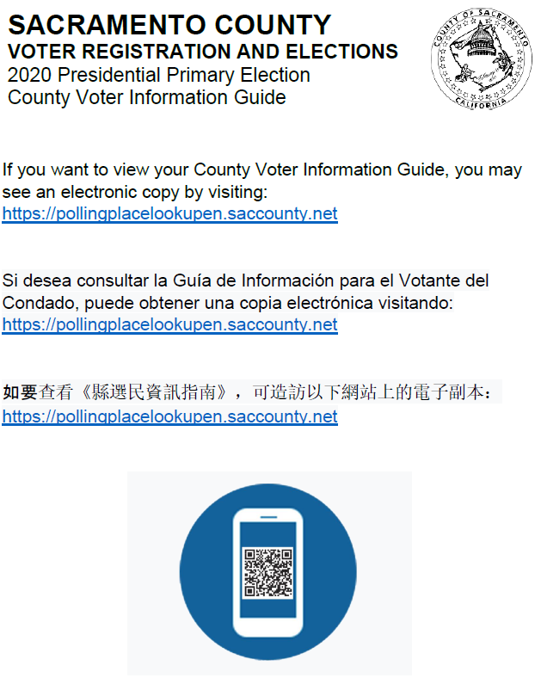
Sou-Jaa A – “CVIG” Baaic nyei Nyungc Zeiv

Sou-Jaa B – Zorng-Mbenc Ginv nyei Dorngx nyei Nyungc Zeiv

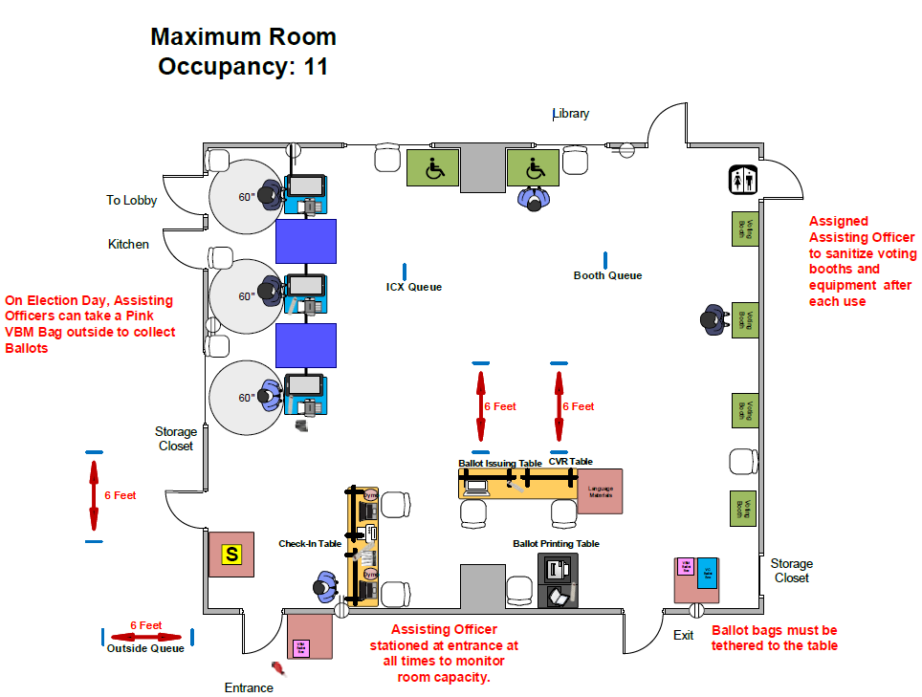

Sou-Jaa C – Fioux Nzengc Ginv nyei Dorngx nyei Yietv-nyeic
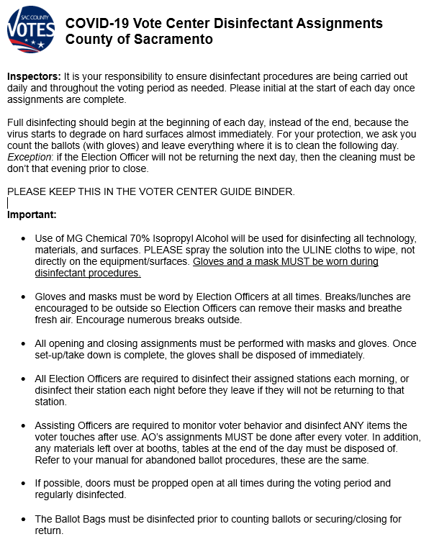

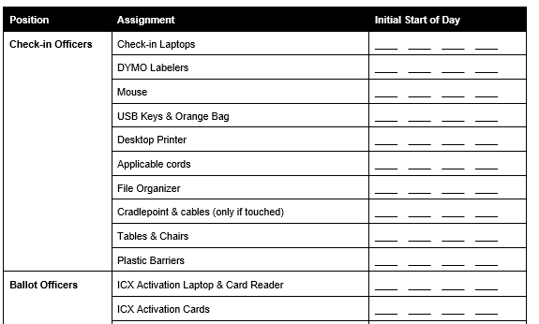

Sou-Jaa D – Ginv nyei Dorngx nyei Baaic nyei Nyungc Zeiv (MAIV GAENGH ZIANGX)

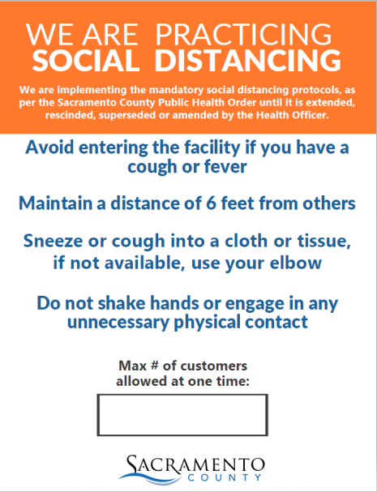
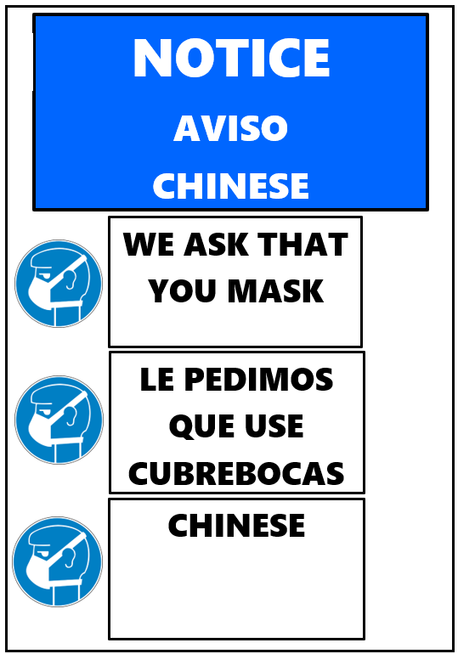

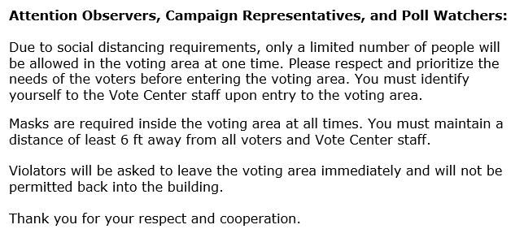

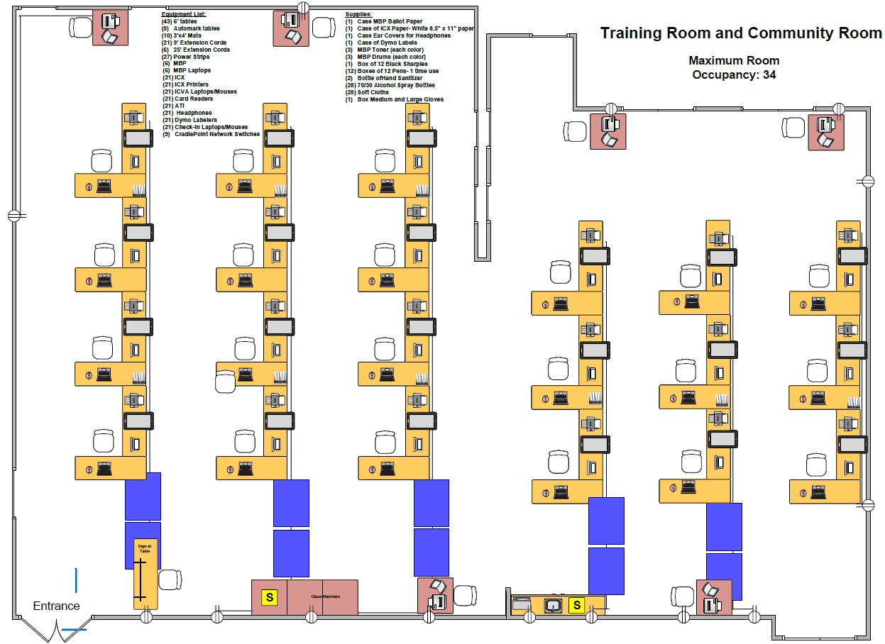
Sou-Jaa E – Mbenc Njaaux Ginv Mienh nyei Gong-Mienh Yiem nyei Dorngx Dauh 17

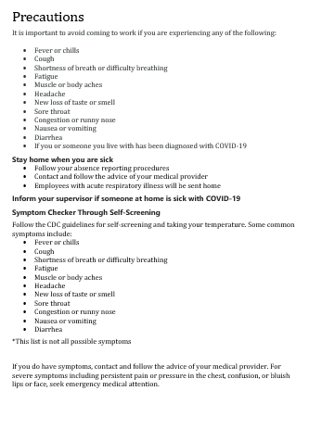
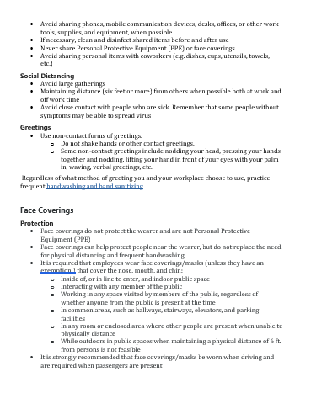
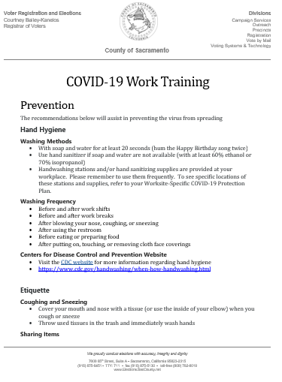
Sou-Jaa F – COVID Njaaux nyei Nyungc Zeiv

Sou-Jaa G – Bun-jaiv La’nyauv Sic nyei Za’eix 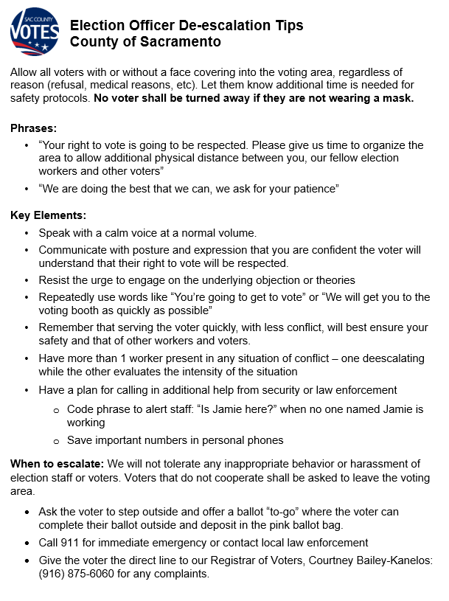
Sou-Jaa H – “VRE” Fioux Nzengc nyei Qorng Zeiv

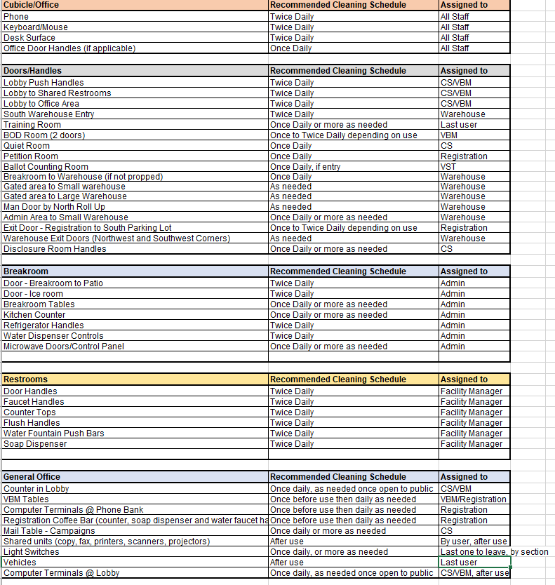

Sou-Jaa I – Zorng-Mbaih Ginv Mienh nyei Yietv-nyeic
