NROOG SACRAMENTO
KEV MUS SAU NPE RAU KEV POV NPAV THIAB KEV XAIV TSA

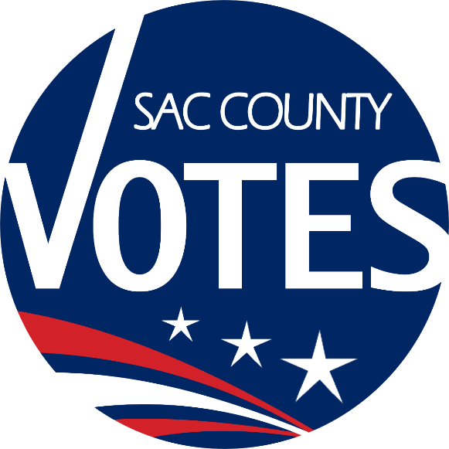

QHOV KEV NPAJ LOS DHIA DEJ NUM HAUV KEV XAIV TSA
KHO DUA TSHIAB RAU COVID-19

Nroog Sacramento
Kev Mus Sau Npe Pov Npav & Kev Xaiv Tsa
7000 65th Street, Suite A
Sacramento, CA 95823
(800) 762-8019
voterinfo@saccounty.net
www.elections.saccounty.net
Lub Rooj Teev Cov Ntsiab Lus Uas Muaj Nyob Hauv Phau Ntawv
I. COV CHAW POV NPAV 4
A. Cov Kev Pab Uas Muaj 4
B. Cov Khoom PPE (Khoom Tiv Thaiv Tus Kheej) Uas Muab Rau Cov Neeg Saibxyuas Kev Xaiv Tsa, Cov Pejxeem Pov Npav, thiab Lwm Cov Neeg Soj Ntsuam Xyuas Ntawm Txhua Lub Chaw Pov Npav Siv. 6
C. Kho & Teeb Cov Chaw: 7
D. Cov Paib 9
E. Kev Muab Ib Lub Chaw Hloov/Kaw 10
F. Chaw Pov Npav/Cov Npav Neeg Xa Rov Qab Tuaj. 10
II. COV NEEG SAIBXYUAS KEV XAIV TSA (NEEG SAIBXUAS CHAW POV NPAV) 10
A. Kev Nrhiav Neeg Tuaj Ua Haujlwm. 10
B. Kev Cob Qhia. 11
C. Cov Neeg Uas Qhia Kom Cov Pejxeem Pov Npav Paub Tias Lawv Yuav Mus Qhov Twg Rau Qhov Twg. 11
D. Cov Sijhawm Muaj Teebmeem. 12
II. COV THAWJ POV NPAV & KEV MUS SAU COV NPAV 12
III. LUB CHAW DHIA DEJNUM RAU KEV MUS SAU NPE POV NPAV & KEV XAIV TSA 13
A. Txoj Kev Npaj Los Teeb Lub Chaw Dhia Dejnum & Kev Kev Npaj Tsuag Tshuaj Tua Kabmob Los Tu Lub Chaw Dhia Dejnum 13
B. Kev Txheeb thiab Suav Npav. 14
C. Cov Neeg Soj Ntsuam Xyuas/Neeg Tshaj Xovxwm 15
IV. KEV HAIS KOM NEEG PAUB & KEV XA XOV 15
A. Kev Pov Npav Xa Hauv Tsev Xa Ntawv Mus (Vote by Mail): Pob Ntawv Pov Npav Siv Rau Txoj Kev Pov Npav Xa Hauv Tsev Xa Ntawv Mus yuav muaj: 15
B. Kev Siv Tau Qhov Kev Pov Npav Vote by Mail (AVBM). 16
C. Daim Ntawv Qhia Kev (Map) Uas Muaj Cov Chaw Pov Npav 16
D. Cov Kev Hais Kom Neeg Paub 17
E. Cov Khoom Siv & Chaw Pab lossis Ntaub Ntawv: 18
Daim Ntawv Tso Nrog Hu Ua A – Paib CVIG Ua Pivtxwv 19
Daim Ntawv Tso Nrog Hu Ua B – Daim Duab Qhia Teeb Lub Chaw Pov Npav Ua Pivtxwv 20
Daim Ntawv Tso Nrog Hu Ua C – Cov Kev Npaj Los Tsuag Tshuaj Tua Kabmob Tu Chaw Pov Npav 21
Daim Ntawv Tso Nrog Hu Ua D – Cov Paib Pivtxwv Rau Lub Chaw Pov Npav (TSEEM TSIS TAU YOG DAIM YUAV SIV) 22
Daim Ntawv Tso Nrog Hu Ua E – Duab Qhia Qhov Kev Cob Qhia Cov Neeg Saibxyuas Kev Xaiv Tsa 23
Daim Ntawv Tso Nrog Hu Ua F – Ntawv Cob Qhia COVID Pivtxwv 24
Daim Ntawv Tso Nrog Hu Ua G – Tswvyim Los Hais Kom Ib Qho Teebmeem Tsis Txhob Loj Ntxiv 26
Daim Ntawv Tso Nrog Hu Ua H – VRE Txoj Kev Npaj Los Tsuag Tshuaj Tua Kabmob Tu Cov Chaw Pov Npav 27
Daim Ntawv Tso Nrog Hu Ua I – Duab Qhia Txoj Kev Txheeb Npav 28

Tshooj Ntawv Piav Qhia Me Ntsis Ua Ntej Txog Cov Ntsiab Lus
Nws tseemceeb tias tsis muaj ib tus pejxeem pov npav yuav tau los mus txiav txim tias saib lawv yuav xaiv lawv txoj kev noj qab nyob zoo lossis kev mus pov npav kom muaj kev nyabxeeb hauv Qhov Kev Xaiv Tsa Tus Thawj Tswjhwm Lub Tebchaws Rau Txhua Tus Neeg (Presidential General Election) thaum Lub Kaum Ib Hlis, Tim 3, 2020. Nyob rau lub sijhawm uas cov pejxeem kis tau tus kabmob coronavirus tseem muaj coob zujzus ntxiv nyob thoob plaws lub tebchaws, Nroog Sacramento yeej sib zog los npaj kom tau ib txoj kev mus pov npav uas txhua tus neeg mus pov tau thiab muaj kev nyabxeeb.
Nroog Sacramento Lub Chaw Voter Registration & Elections (VRE) yuav tsum nrhiav kom tau txhiab txhiab tus pejxeem uas mob siab los pab pejxeem los mus dhia cov dejnum hauv ib qho kev xaiv tsa. Nroog Sacramento lub homphiaj dav yuav yog los dhia ib qho kev xaiv tsa raws li txoj kev npaj thaum xub thawj hauv tsab cai Voter's Choice Act, uas yuav muaj qhib cov Chaw Pov Npav (Vote Centers) ntau npaum li qub rau 11 hnub thiab 4 hnub zoo li peb qhib thaum Lub Peb Hlis Ntuj rau Qhov Kev Xaiv Tsa Tus Thawj Tswjhwm Lub Tebchaws Thawj Lwm (Presidential Primary Election). Tiamsis, cov chaw peb yuav muaj yuav yog nyob ntawm saib peb nrhiav puas tau cov chaw thiab cov Neeg Saibxyuas Kev Xaiv Tsa.
Nroog Sacramento cov kev npaj los dhia qhov kev xaiv tsa ntawm no kom tau raws li Lub Xeev Tus Kws Tuav Ntaub Ntawv Cov Lus Qhia Uas Xav Kom Ua Tau Los Dhia Kev Xaiv Tsa Thaum Muaj Tus Kabmob COVID-19 (Secretary of State’s Election Administration Guidance under COVID-19).
Peb lub homphiaj yog los mus xyuas kom meej tias peb cov pejxeem pov npav thiab cov neeg ua haujlwm saibxyuas kev pov npav yeej tseem muaj kev nyabxeeb thiab ntsib kev noj qab nyob zoo thaum lawv los ua qhov dejnum tseemceeb ntawm no rau peb lub zejzos. Txoj kev npaj los dhia dejnum ntawm no yuav qhia tias saib peb yuav ua li cas peb thiaj li yuav ua tau raws li lub homphiaj ntawd los ntawm txoj kev siv Cov Chaw Pov Npav (Vote Centers), Kev Cob Qhia Cov Neeg Saibxyuas Kev Xaiv Tsa (Election Officer) (Neeg Ua Haujlwm Saibxyuas Kev Pov Npav (Poll Worker)), Cov Thawv Pov Npav (Ballot Drop Boxes), Kev Txheebxyuas Npav (Ballot Processing), Cov Neeg Soj Ntsuam Xyuas/Neeg Tshaj Xovxwm (Observers/Media), thiab Kev Tshaj Tawm Kom Neeg Paub/Kev Xa Xov Tawm (Outreach/Messaging).
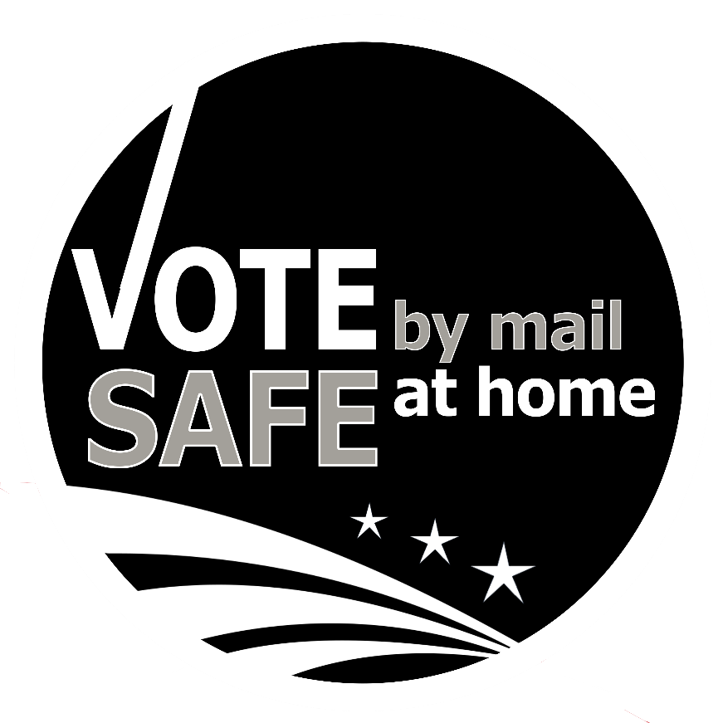

COV CHAW POV NPAV

Cov Kev Pab Uas Muaj
    - Kev mus tau tus kheej mus pov npav lossis qhov pov npav hu uaBallot "to-go". Cov kev pab yuav muaj zoo li qub nyob rau ntawm txhua Lub Chaw Pov Npav. Cov pejxeem pov npav yeej tseem yuav mus tau koj tus kheej mus pov npav lossis mus nqa tau lawv daim npav nyob ntawm ib Lub Chaw Pov Npav (Vote Center). Ntxiv ntawd, ib tus pejxeem pov npav, lossis ib tus neeg uas tus pejxrveem pov npav tso cai rau, yuav hais tau kom tus pejxeem pov npav muab ib Daim Ntawv Teev Npe Tso Cai Rau Ib Tus Neeg (Ballot Pick-up Authorization form) sau kom tiav sub lwm tus neeg thiaj li yuav mus nqa tau ib daim npav rau ib tus pejxeem pov nyob nyob ntawm 7000 65th Street, Ste A, lossis ib Lub Chaw Pov Npav (Vote Center). Qhov no yuav pub tus neeg mus nqa ib daim npav coj los rau tus pejxeem pov npav khij cov kev xaiv uas tus pejxeem pov npav pom zoo. Peb pom zoo kom muab cov npav ntawm no coj mus pov rau ntawm ib Lub Thawv Pov Npav (Ballot Drop Box) lossis ib Lub Chaw Pov Npav (Vote Center).
    - Kev Mus Pov Tau Npav.Kev Pov Npav Ntawm Ntug Kev (Curside Voting) thiab yuav muaj tsawg kawg los kom muaj Cov Tshuab Rau Neeg Xiam Oob Qhab Siv Los Khij Npav (Accessible Ballot Marking Devices (Dominion's ImageCast X devices, hu ua "ICX")) li ntawm peb lub rau neeg siv nyob rau ntawm txhua Lub Chaw Pov Npav (Vote Center).
    - Kev Pab Cov Pejxeem Pov Npav.
      - Peb yuav muaj Khoom Thaiv (Guide Tethers) los pab qhia cov pejxeem pov npav uas dig muag lossis tsis pom kev zoo mus rau ntawm ib lub rooj pov npav, ib lub tshuab ICX, ib lub rooj, lossis coj mus rau ntawm lub chaw sawv tos.
      - Peb yuav qhia rau cov pejxeem pov npav uas muaj kev xiam oob qhab kom lawv hais rau ib tus Neeg Saibxyuas Kev Xaiv Tsa paub thaum lawv nkag los rau hauv ib chav pov npav sub tus Neeg Saibxyuas Kev Xaiv Tsa thiaj li yuav nrhiav tau cov kev pab tsim nyog rau lawv.
      - Peb yuav pub coob txog li ob tus neeg nkag nrog ib tus pejxeem pov npav los pab nws. Peb yuav muaj cov ntaub npog qhov ncauj qhov ntswg rau txhua tus neeg, suav nrog rau cov menyuam yaus.
      - Yog tias ib tus pejxeem pov npav siv tsis tau lossis tsis kam siv ib daim ntaub npog qhov ncauj qhov ntswg, tus Neeg Saibxyuas Kev Xaiv Tsa yuav tsum nyob deb li 6 kauj ruam ntawm tus pejxeem pov npav txhua lub sijhawm. Yog tias ib tus pejxeem pov npav siv tsis tau lossis tsis kam siv ib daim ntaub npog qhov ncauj qhov ntswg tiamsis tus Neeg Saibxyuas Kev Xaiv Tsa yuav tsum tau los nyob ze tshaj 6 kauj ruam ntawm tus pejxeem pov npav los mus pab nws, tus Neeg Saibxyuas Kev Xaiv Tsa yuav tsum tau siv daim ntaub npog qhov ncauj qhov ntswg nrog ib daim thaiv ntsej muag (face shield) lossis siv ib yam khoom dabtsi los ua kev tiv thaiv ntxiv.
    - Khoom/Ntaub Ntawv Tuav Tau Ntawm Tes.
      - Peb yuav muaj lub Xeev Cov Phau Ntawv Qhia Txog Kev Pov Npav Rau Cov Pejxeem Pov Npav (State Voter Information Guides) thiab cov ntaub ntawv qhia txog cov cai muaj rau neeg los mus muab kev pom zoo nyob rau ntawm lub rooj hu ua Lub Rooj Muaj Ntaub Ntawv Hais Ua Lwm Yam Lus (Language Material Table). Tiamsis, peb yuav muaj ib daim paib uas muaj cov lej QR codes rau cov pejxeem pov npav los nkag mus saib lawv Lub Nroog Cov Lus Qhia Txog Kev Pov Npav Rau Cov Pejxeem Pov Npav (County Voter Information Guide) lossis Lub Xeev Cov Lus Qhia Txog Kev Pov Npav Rau Cov Pejxeem Pov Npav nyob hauv lawv cov xovtooj. Peb los kuj yuav hais kom cov pejxeem pov npav siv lawv daim npav uas yog daim siv los ua qauv, uas muaj nyob hauv lawv phau ntawv County Information Guide, los mus khij cov lawv pom zoo ua ntej lawv yuav mus rau ntawm Cov Chaw Pov Npav thiab los mus pab kom lawv tsis txhob tau nyob ntev ntawm chav pov npav. (Mus xyuas Daim Ntawv Tso Nrog Hu Ua A los ua pivtxwv)
      - Peb yuav tsis siv cov Secrecy Sleeves (cov hnab ntawv uas muab tus neeg lub npe thiab tus ntawv tes kos npe ntsaws rau ib kem uas txawv kem ntsaws ntawm daim npav). Qhov peb kom ua, yog tias ib tus pejxeem pov npav tsis xav kom lwm tus neeg pom, peb yuav hais kom lawv muab lawv daim npav tais quav hauv nruab nrab tom qab lawv khij tag.
      - Peb yuav tsis muaj Cov Ntawv Nug Saib Neeg Xav Li Cas Rau Lub Chaw Pov Npav (Vote Center Experience Survey) rau qhov kev xaiv tsa zaum no. Qhov peb ua, peb yuav muab ib daim npav rau neeg hu mus yog lawv muaj lus nug, lus hnyav siab, tswvyim, hais txog kev pov npav, lossis los mus nug txog lawv daim npav.
      - Txawm tias peb yuav muab ib daim npav txhais ua lwm yam lus los siv ua qauv, uas muab hu ua peb Daim Npav Txhais Ua Qauv (Ballot Translation Guide), los tus Neeg Txheeb Npe (Check-in Officer) yeej tseem yuav luam tau rau cov neeg yog thaum twg lawv thov.

Cov Khoom PPE (Khoom Tiv Thaiv Tus Kheej) Uas Muab Rau Cov Neeg Saibxyuas Kev Xaiv Tsa, Cov Pejxeem Pov Npav, thiab Lwm Cov Neeg Soj Ntsuam Xyuas Ntawm Txhua Lub Chaw Pov Npav Siv.
    - Cov ntaub npog qhov ncauj qhov ntswg uas nyias ntim nyiaj hnab, suav nrog rau cov hauv menyuam yaus siv
      - Peb yeej xav kom cov pejxeem pov npav siv ntaub npog qhov ncauj qhov ntswg, tiamsis peb yuav tsis hais kom lawv tsis txhob nkag mus pov npav txawm tias lawv yeej tsis siv ib daim ntaub npog qhov ncauj qhov ntswg.
      - Peb yuav muab ib daim ntaub npog qhov ncauj qhov ntswg rau txhua tus pejxeem pov npav uas tsis muaj ib daim.
      - Peb yuav muaj ib co lus rau Cov Neeg Saibxyuas Kev Xaiv Tsa siv los mus daws cov teebmeem ntawm no (Mus xyuas ntawm (II)(D) Cov Teebmeem Nyuaj)
    - Muaj hnab looj tes nyob rau ntawm txhua Tus Neeg Saibxyuas Kev Xaiv Tsa lub rooj ua haujlwm
      - Hloov rau ib lub hnab looj tes tshiab tom qab pab txhua tus pejxeem pov npav lossis tom qab tau nrog neeg sibtham
      - Yog tsis muaj hnab looj tes, siv tshuaj tua kabmob (hand sanitizer) los npleev tes tom qab pab txhua tus pejxeem pov npav tas
    - Cov cwjmem uas muab pov tseg tom qab siv ib zaug tas
    - Tshuaj Tua Kabmob Npleev Tes, nyob rau txhua qhov chaw hauv Lub Chaw Pov Npav thiab ntawm Cov Neeg Saibxyuas Kev Xaiv Tsa cov rooj ua haujlwm, los rau neeg siv thaum lawv nkag los
    - Peb los kuj yuav muaj cov khoom sivThaiv Ntsej Muag (Face Shields), yog thaum twg neeg thov, rau cov pejxeem pov npav uas tsis kam siv cov ntaub npog qhov ncauj qhov ntswg
    - Cov Txiag Yas Uas Siv Los Thaiv
    - Peb yuav siv cov Cawv Cuaj Caum uas muaj cov tshuaj MG Chemicals li 70% los mus so:
      - Cov tshuab ICX, txhua zaug tom qab ib tus neeg siv tas
      - Cov Npav Qhib Lub Tshuab ICX (ICX Activation Cards)
      - Cov rooj pov npav, txhua zaug tom qab ib tus neeg siv tas
      - Cov Saibxyuas Kev Xaiv Tsa cov laptops, tshuab luam ntawv, cov tshuab DYMO Labelers, cov chaw ntsia USB, suav nrog rau lub tshuab luam npav Mobile Ballot Printer
      - Cov Hnab Ntim Npav, txhua zaug tom qab muaj neeg chwv tas
      - Cov Txiag Yas Uas Siv Los Thaiv: tsuas yog thaum muaj neeg chwv, txham rau, hnoos rau, lossis tom qab pab ib tus pejxeem pov npav uas tsis siv ib daim ntaub npog qhov ncauj qhov ntswg
      - Khoom Thiav Qhia Kev (Guide Tethers)
      - Rooj Cia Khoom & Rooj Zaum, txhua zaug tom qab ib tus neeg siv tas
      - Cov Hlua Cab Thaiv Los Qhia Kev (Stanchions)
Peb yuav muab cov Ntawv Muaj Lus Qhia Txog Kev Nyabxeeb Hauv Kev Raug Tshuaj (Material Safety Data Sheets (MSDS)) rau txhua Lub Chaw Pov Npav uas yuav muaj lus qhia tias lawv yuav kho cov neeg ua haujlwm li cas, yog tias lawv tau raug ib yam tshuaj dabtsi.

Kho & Teeb Cov Chaw:
    - Peb yuav muaj ib daim paib uas qhia tias saib yuav pub pes tsawg leej neeg nkag mus rau hauv qhov chaw pov npav rhais nyob rau ntawm txhua Lub Chaw Pov Npav. Qhov no yog suav tag nrho cov pejxeem pov npav, cov neeg soj ntsuam xyuas, cov phooj ywg/tsev neeg uas nkag mus pab tus pejxeem pov npav, thiab cov Neeg Saibxyuas Kev Xaiv Tsa. Tus qauv uas siv los qhia tias pub pes tsawg leej nkag mus ntawm no yog ib tus neeg rau 100 kauj ruam ib puag ncig (square feet). Cov Neeg Saibxyuas Kev Xaiv Tsa, muaj npe hu ua Cov Neeg Pab, uas sawv nraum zoov ntawm txhua Lub Chaw Pov Npav yuav muaj feemcuam los mus:
      - Soj ntsuam xyuas qhov tias muaj neeg pes tsawg leej nyob hauv chav pov npav (peb yuav muaj cov xovtooj sibtham ntawm tes (walkie-talkie) siv nyob rau ntawm cov chaw pov npav uas dav)
      - Txais Cov Npav Xa Hauv Tsev Xa Ntawv Mus uas cov pejxeem pov npav nqa tuaj pov. Cov pejxeem pov npav uas nqa lawv cov npav tuaj pov xwb yuav nkag tsis tau mus rau hauv chav pov npav, tshwj tias lawv thov lwm yam kev pab ntxiv. Peb yuav muaj cov tshuaj lo ntawv (glue) nyob rau ntawm txhua Lub Chaw Pov Npav rau neeg siv los lo lawv cov hnab ntawv.
      - Muab cov ntaub npog qhov ncauj qhov ntswg uas nyias ntim nyias ib lub hnab rau txhua tus pejxeem pov npav uas tsis muaj ib daim, suav nrog rau muab cov ntaub npog qhov ncauj qhov ntswg rau cov menyuam yaus lossis lwm cov neeg uas yuav tau pab tus pejxeem pov npav.
      - Cov Neeg Soj Ntsuam Xyuas.Cov Neeg Soj Ntsuam Kev Pov Npav (Poll Watchers), Cov Neeg Ntsuam Xyuas (Monitors), Cov Neeg Sawv Cev Kev Sibtw (Campaign Representatives) yuav nkag tsis tau mus rau hauv chav pov npav yog lawv tsis siv ib daim ntaub npog qhov ncauj qhov ntswg. Yeej tsis muaj kev zam li.
      - Cov Chaw Pov Npav uas tsis muaj ib qhov chaw nkaum tshav nkaum nag sab nraum zoov, peb yuav teeb ib co tsev nkaum tshav nkaum nag rau sab nraum zoov.
    - Rau Cov Chaw Pov Npav uas muaj ntau tshaj ib lub qhov rooj, peb yuav muaj paib qhia tias lub twg yog "Lub Qhov Rooj Nkag" thiab lub twg yog "Lub Qhov Rooj Tawm". Rau Cov Chaw Pov Npav uas muaj ib lub qhov rooj nkag/tawm xwb, tus Neeg Pab yuav tswj kom tsis pub muaj neeg coob los sib txiv nyob ntawm lub qhov rooj.
    - Txhua Lub Chaw Pov Npav yuav muaj ib daim duab qhia tias yuav teeb lub chaw ntawd zoo li cas neeg thiaj li yuav nkag tau mus coob tshaj thiab qhia tias kom muab cov neeg sawv qhov twg rau qhov twg thiaj li yuav ua tau kom muaj kev nyob tau nrug deb. (Mus xyuas Daim Ntawv Tso Nrog Hu Ua B los ua pivtxwv)
    - Peb yuav siv cov ntaub nplaum xiav uas neeg siv thaum lawv pleev xim rau tsev coj los cim cov chaw uas cov pejxeem pov npav yuav tsum tau sawv thaum lawv tseem tab tom tos los mus txheeb npe nkag, tab tom tos lawv daim npav lossis daim npav qhib lub tshuab ICX, tab tom tos cov rooj pov npav, lossis tab tom tos mus siv ib lub tshuab ICX. Cov Neeg Saibxyuas Kev Xaiv Tsa (teeb rau sab nraum zoov) thiab peb Cov Neeg Xa Khoom (Chaser team) (teeb rau sab hauv tsev) yuav yog cov muab ntaub nplaum los cim cov chaw no.
    - Peb yuav cab hlua nyob rau ntawm cov Chaw Pov Npav Loj los pab qhia tias saib neeg yuav sawv tos zoo li cas nyob rau sab hauv tsev thiab sab nraum zoo ntawm Lub Chaw Pov Npav.
    - Peb yuav siv cov txiag yas coj los thaiv nyob rau ntawm Tus Neeg Txheeb Npe lub rooj ua haujlwm, ntawm Tus Neeg Txheeb Npav lub rooj ua haujlwm, thiab ntawm Tus Neeg CVR lub rooj ua haujlwm. Peb yuav muab txiag yas ntxiv rau txhua lub chaw coj mus thaiv lossis siv rau ntawm tej qhov chaw uas tsim nyog siv.
    - Peb yuav hais kom tus tswv ntawm lub chaw muab rooj zaum ntxiv coj los rau peb siv lossis VRE yuav tsum tau nrhiav yog tias tus tswv ntawm lub chaw muab tsis tau 20 lub rooj zaum ntxiv coj los rau peb siv. Cov rooj zaum no yog tseg rau cov pejxeem pov npav uas sawv tos tau zaum.
    - Peb yuav npaj ib lub “Chaw Tu Kom Muaj Huv Saib (Sanitation Station)” (qhia nyob hauv Daim Ntawv Tso Nrog Hu Ua A uas muaj tus ntsiaj ntawv “S”) uas muaj tshuaj tua kabmob thiab ntawv so tes.
    - Txhua lub chaw rau kev huv siab yuav muaj hnab rau neeg pov cov khoom pov tsegcov ntaub npog qhov ncauj qhov ntswg, hnab looj tes, cwjmem uas siv tag lawm, tej yam zoo li no.
    - Tus Neeg Txheeb Npav lossis Tus Neeg CVR yuav muab cov cwjmem uas siv tau ib zaug xwb rau cov pejxeem pov npav. Peb yuav muaj cwjmem nyob ntawm Tus Neeg Txheeb Npe lub r ooj ua haujlwm, nrog cov ntawv sau ua si, los mus pab daws cov teebmeem ntawm txoj kev txuaslus.
    - Peb yuav muab lus qhia tias yuav tau cov chawv pov npav li cas rau txhua Lub Chaw Pov Npav nyob hauv phau ntawv Voter Center Guide Binder (Mus xyuas ntawm Daim Ntawv Tso Nrog Hu Ua C los ua ib qho pivtxwv). Cov Neeg Saibxyuas Kev Xaiv Tsa yuav tsum tau mus tsuag tshuaj tua kabmob los tu lawv cov chaw ua haujlwm thaum sawv ntxov txhua hnub, thiab thaum tsaus ntuj yog tias lawv yuav tsis rov qab tuaj siv lub rooj ua haujlwm ntawd ntxiv hnub tom qab. Cov Neeg Pab yuav yog cov muaj feemcuam los mus tsuag tshuaj tu thiab saibxyuas cov rooj pov npav thiab cov tshuab ICX.
    - Peb yuav muaj kev tu txhua yam kom huv, suav nrog rau kev ntxuav txhua qhov chaw, hauv pem teb (floors), cov chaw neeg chwv, thiab siv cov ntxaij lim cua HEPA, rau txhua Lub Chaw Pov Npav siv.

  - Cov Paib – Daim Ntawv Tso Nrog Hu Ua D Yog Cov Pivtxwv
    - "Peb Thov Kom Koj Siv Ntaub Npog Qhov Ncauj Qhov Ntswg", hais ua peb yam lus, nyob hauv tsev thiab nraum zoov ntawm txhua Lub Chaw Pov Npav
    - Paib Qhov Rooj Tawm/Nkag, ua peb yam lus
    - Paib Rau Cov Neeg Soj Ntsuam Xyuas/Neeg Soj Ntsuam Kev Pov Npav, hais ua lus Askiv xwb
    - Cov Qhia Qhov Neeg Coob Tshaj Uas Nroog Sacramento Pub Nkag Mus, cov lagluam nyob Nroog Sacramento twb siv lawm, hais ua peb yam lus
    - Cov paib "Sawv Ua Ib Kab Ntawm No"
    - Cov Najnpawb, yuav muab lo rau ntawm cov rooj pov npav
    - Paib Qhia Lub Chaw Tu Kom Muaj Kev Huv Siab

  - Kev Muab Ib Lub Chaw Hloov/Kaw. Nws yeej muaj qhov tias tom qab muab cov chaw luam tag rau hauv peb phau ntawv County Voter Information Guide, ib Lub Chaw Pov Npav yuav tsis qhib, vim lub tsev lossis vim nrhiav tsis tau Cov Neeg Saibxyuas Kev Xaiv Tsa. Yog tias muaj tshwmsim zoo li no, Nroog Sacramento yuav ua zoo li nram qab no:
    - Muab ib daim txiag muaj paib tso rau ntawm lub chaw uas muab kaw lawm nrog ib daim ntawv teev cov Chaw Pov Npav nyob ze tshaj thiab ib daim duab qhia kev (map) mus rau ntawm cov chaw ntawd
    - Tso ob tus neeg mus sawv nraum zoov ntawm lub chaw uas muab kaw lawm los siv ib lub hnab xim liab dawb (pink) los mus txais Cov Npav Xa Hauv Tsev Xa Ntawv Mus uas neeg nqa tuaj pov
    - Mus muab peb lub vassab (website), qhov txujci (tool) nrhiav pejxeem pov npav, qhov SacVote app kho dua, thiab tso lus tshaj tawm hauv xovxwm
    - Nco ntsoov qhia kom txhua tus neeg hu thiab txais xovtooj hauv VRE paub txog qhov uas muab lub chaw hloov lossis kaw

  - Chaw Pov Npav/Cov Npav Neeg Xa Rov Qab Tuaj. Cov neeg ua haujlwm hauv Lub Chaw Pov Npav thiab Cov Neeg Thauj Npav yuav tsum tau siv hnab looj tes thaum lawv thauj khoom. Cov neeg ua haujlwm nyob ntawm VRE yuav siv ib nkawm hnab looj tes tshiab los txais cov khoom thiab npav uas thauj ntawm txhua lub chaw pov npav los lossis txhua Tus Neeg Thauj Npav thauj los. Cov Neeg Thauj Npav uas siv lub Nroog ib lub tsheb lossis tsheb xauj yuav tsum tau siv tshuaj tua kabmob los tu lub tsheb ua ntej lawv lub sijhawm ua haujlwm xaus.

COV NEEG SAIBXYUAS KEV XAIV TSA (NEEG SAIBXUAS CHAW POV NPAV)
  - Kev Nrhiav Neeg Tuaj Ua Haujlwm. Thaum Lub Xya Hli ntawm 2020, peb tau xa ntawv mus rau coob tshaj 10,000 Tus Neeg Saibxyuas Kev Xaiv Tsa uas Nroog Sacramento muaj npe khaws tseg mus nug saib lawv puas yuav khoom tuaj ua haujlwm. Cov Neeg Saibxyuas Kev Xaiv Tsa yuav muab daim ntawv sau thiab xa tau rov qab tuaj, uas peb twb them nqi xa ua ntej lawm, lossis nkag mus rau hauv online los mus lees paub tias lawv yeej khoom tuaj ua haujlwm rau Qhov Kev Xaiv Tsa Thaum Lub Kaum Ib Hlis, Tim 3, 2020Ntxiv ntawd, peb yuav muaj chaw rau Cov Neeg Saibxyuas Kev Xaiv Tsa los mus sau lawv cov lus hnyav siab txog qhov kev xaiv tsa ntawm no, uas feem ntau yog hnyav siab txog cov khoom tiv thaiv tus kheej (PPE) uas peb muaj rau lawv siv. Peb yuav sib zog txog li qhov peb ua tau los nrhiav kom muaj Cov Neeg Saibxyuas Kev Xaiv Tsa "npaj tseg" uas peb yuav xa tau mus pab cov chaw uas muaj neeg tuaj pov npav coob lossis mus hloov ib tus neeg.

  - Kev Cob Qhia. Peb yuav muab feem ntau ntawm cov ntaub ntawv siv los cob qhia coj mus tso rau hauv lub chaw Election Officer EasyVote portal uas yuav muaj sau ua PowerPoint nrog duab thiab suab thiab yeeb yaj kiab. Peb los yeej tseem yuav tsum tau muaj ib qho kev cob qhia tim ntsej tim muag tsawg tsawg rau Cov Neeg Saibxyuas Kev Xaiv Tsa nyob rau ntawm VRE lub chaw dhia dejnum loj ntawm 7000 65th Street. Qhov kev cob qhia no yuav yog ib qho uas cov neeg "xyaum ua cov dejnum" siv cov laptops txheeb npe, cov Tshuab Luam Ntawv, thiab cov Tshuab ICX.Txhua tus neeg mus kawm yuav tau txais lawv cov khoom siv thiab peb yuav tsum muaj neeg txaus mus kawm txhua qhov kev cob qhia peb thiaj li yuav qhia tau. Daim Ntawv Tso Nrog Hu Ua E qhia cov ntaub ntawv uas peb yuav siv los qhia cov neeg "xyaum ua cov dejnum". Tag nrho Cov Neeg Saibxyuas Kev Xaiv Tsa yuav tsum tau siv cov ntaub npog qhov ncauj qhov ntswg txhua lub sijhawm thaum lawv nyob hauv qhov kev cob qhia thiab thaum lawv nyob hauv cov Chaw Pov Npav.

Ntxiv ntawd, Cov Neeg Saibxyuas Kev Xaiv Tsa yuav tsum tau mus kawm qhov kev cob qhia txog tus kabmob COVID-19 uas Sacramento County Department of Personnel Services npaj los rau neeg kawm (Daim Ntawv Tso Nrog Hu Ua F). Cov Neeg Soj Ntsuam (Inspectors) los kuj tseem yuav tau muab cov kev npaj los tsuag tshuaj tua kabmob tu cov chaw thiab cov lus qhia txog kev nyabxeeb rau ib lub chaw coj los nrog lawv cov Neeg Saibxyuas Kev Xaiv Tsa sibtham. Cov Neeg Saibxyuas Kev Xaiv Tsa yuav kos lawv lub npe rau ntawm daim ntawv them nyiaj ua haujlwm los mus lees paub tias lawv yeej kawm qhov kev cob qhia lawm.

  - Cov Neeg Uas Qhia Kom Cov Pejxeem Pov Npav Paub Tias Lawv Yuav Mus Qhov Twg Rau Qhov Twg. Peb yuav muaj cov Neeg Pab coob leej ntxiv los pab pejxeem nyob rau ntawm txhua Lub Chaw Pov Npav.Cov Neeg Pab ntawm no yuav nyob rau sab nraum zoov ntawm Lub Chaw Pov Npav nrog ib lub hnab ntim npav xim liab dawb (pink) los mus txais cov npav khij tiav tag lawm uas neeg nqa tuaj pov. Ntxiv ntawd, cov Neeg Pab ntawm no yuav saib xyuas qhov tias saib muaj pes tsawg leej neeg nyob hauv chav pov npav txhua lub sijhawm, siv cov xovtooj tuav ntawm tes (walkie talkies) thaum yuav tsum tau siv, thiab muab cov ntaub npog qhov ncauj qhov ntswg thiab cov khoom thaiv ntsej muag (face shield) rau cov neeg uas tsis muaj. Cov Neeg Pab ntawm no yuav khuam cov paib ua haujlwm uas muaj txoj hlua khuam liab dawb (pink) los qhia tias lawv yog cov Neeg Saibxyuas Kev Xaiv Tsa. Peb yuav cob qhia cov Neeg Pab ntawm no tsis tseg hais txog txoj kev txheebxyuas cov ntawv tes kos npe nyob ntawm lub hnab ntawv uas neeg ntim npav xa rov qab thiab lawv yuav muaj cov tshuaj lo ntawv (glue) rau cov pejxeem pov npav siv. Peb yuav muaj hnab looj tes thiab tshuaj tua kabmob pleev tes (hand sanitizer) rau neeg siv thiab cov Neeg Pab yuav tsum siv hnab looj tes thaum lawv txais cov npav lossis thaum lawv txais lossis muab ntaub ntawv rau neeg.

  - Cov Sijhawm Muaj Teebmeem. Cov Kev Xaiv Thawj Tswjhwm Rau Txhua Tus Neeg (Presidential General Elections) yeej yog ib qho nyuaj thiab muaj neeg hais lus tsis sib haum. Nyob rau lub sijhawm muaj kev sibkis kabmob loj zoo li tam sim no, peb yeej xav tias qhov teebmeem no yeej yuav tsum muaj ntau tshaj ntxiv thiab yuav tsum muaj neeg cav ncauj hais txog txoj kev siv ntaub npog qhov ncauj qhov ntswg, kev ruaj ntseg hauv kev xaiv tsa, thiab yeej yuav tsum muaj neeg sawv coob tos.Ntxiv rau txoj kev xa xov thiab kev hais rau cov pejxeem pov npav kom lawv paub tias tej zaum yuav muaj neeg coob sawv tos nyob rau Hnub Muaj Kev Xaiv Tsa, peb yeej sib zog los npaj tswvyim rau peb cov Neeg Saibxyuas Kev Xaiv Tsa kom lawv ua tau qhov muaj kev nyabxeeb rau lawv tus kheej thiab daws tau cov teebmeem uas muaj tshwmsim. Nroog Sacramento yuav muab Lub Xeev Tus Kws Tuav Ntaub Ntawv Cov Lus Qhia Kom Ua coj los siv uas yog muaj nyob rau hauv phau ntawv Vote Center Guide Binder hais txog kev daws cov teebmeem uas muajt tshwmsim (Daim Ntawv Tso Nrog Hu Ua G).

Ntxiv ntawd, peb yeej muab txhua lub Chaw Pov Npav hais qhia mus rau cov Tub Ceevxeem Hauv Cov Nroog Loj (County Sheriff) thiab cov Tub Ceevxwm Hauv Cov Nroog Me (City Police Departments) kom lawv paub nyob tsam ho muaj cov teebmeem zoo li no tshwmsim. Peb ntsuas hu rau cov tub ceevxwm hauv cov nroog me lossis nroog loj xwb yog tias cov Neeg Saibxyuas Kev Xaiv Tsa yeej daws tsis tau ib qho teebmeem lossis qhov kev muaj neeg sib cav.

- COV THAWJ POV NPAV & KEV MUS SAU COV NPAV. Nroog Sacramento tau nug mus rau cov khw muag khoom noj thiab cov khw muag khoom siv nyob hauv lub Nroog saib lawv puas kam kom peb muab cov thawv pov npav coj mus teeb rau ntawm cov khw. Raley's/Bel-Air pom zoo los cia peb muab Cov Thawv Pov Npav coj mus teeb rau ntawm lawv cov khw thiab VRE yuav siv txhua lub khw lawv muaj nyob hauv Nroog Sacramento. VRE los tseem yuav koomtes nrog Sacramento Public Libraries los mus teeb kom muaj cov Thawv Pov Npav nyob rau ntawm cov tsev cia ntawv thiab ntawm peb lub Nroog Cov Chaw Dhia Dejnum. Peb lub homphiaj yog yuav tsum kom muaj 58 Lub Thawv Pov Npav qhib pib thaum Lub Kaum Hli, Tim 5. Peb yuav muaj ob lub thawv teeb rau nraum zoov uas qhib 24 teev nyob rau ntawm VRE thiab ntawm lub tsev haujlwm Citrus Heights City Hall.

Peb yuav muab cov chaw uas peb nrhiav tau lawm coj los tso rau hauv VRE lub vassab (website) thaum ib nrab ntawm Lub Cuaj Hli, thiab yuav muab tso rau hauv phau ntawv County Voter Information Guide thiab hauv cov pejxeem pob ntawv Vote by Mail.
Vim qhov kev cov nyom hais txog United States Postal Service, VRE yeej nrog peb tus neeg sawv cev cov tsev xa ntawv hauv lub nroog txuaslus tsis tseg. Txawm tias qhov teebmeem yuav muaj mus zoo li cas nyob rau lub sijhawm uas Lub Kaum Ib Hli Ntuj los ze zujzus lawm, cov teebmeem yeej muaj nyob thoob plaws lub tebchaws. VRE yeej npaj tias yuav muaj neeg coob nqa npav tuaj pov; yog li ntawd, peb yeej muaj ntau lub thawv pov npav nyob rau ntawm peb txhua lub chaw. Peb yuav muaj neeg mus txheebxyuas cov thawv pov npav thiab mus nqa cov npav raws li Cov Kev Nqa Npav Thaum Muaj Xwmceev (Emergency Ballot Pick-up standards).
Peb thov caw cov koomhaum nrog peb koomtes hauv lub zejzos los mus pab VRE sau cov npav, tshwjxeeb tshaj yog thaum twg peb xav tau neeg pab thiab thaum twg VRE tsis muaj neeg mus sau cov npav. Cov koomhaum nrog peb koomtes yuav yog cov muaj cai los txais cov npav sawv cev VRE, zoo ib yam li qhov uas peb tso cai rau txhua lub chaw uas muaj cov Thawv Pov Npav los txais npav. Peb yeej muaj cov ntawv teev npe thiab cov kev dhia dejnum ntawm Kev Ceev Cov Npav coj los rau cov neeg pab haujlwm dawb hauv lub zejzos los mus pab sau cov npav. Registrar of Voters yog lub chaw yuav muab kev pom zoo rau ib qho kev mus sau npav thiab yuav tsum txiav txim raws li peb cov cai thiab cov kev npaj los dhia dejnum.

LUB CHAW DHIA DEJNUM RAU KEV MUS SAU NPE POV NPAV & KEV XAIV TSA
  - Txoj Kev Npaj Los Teeb Lub Chaw Dhia Dejnum & Kev Kev Npaj Tsuag Tshuaj Tua Kabmob Los Tu Lub Chaw Dhia Dejnum. Hauv Lub Plaub Hlis thiab Lub Tsib hlis, VRE tau sib zog los ua kom muaj kev nyabxeeb nyob rau ntawm 7000 65th Street. Qhov no yog muaj:
    - Cov txiag yas txav tau uas muab siv coj los thaiv ntawm lub rooj txais qhua thaum tseem tsis tau muaj ib daim txiag yas ntsias rau ntawd los thaiv
    - Cov txiag yas thaiv hauv nruab nrab ntawm cov kem chaw ua haujlwm (cubicles), suav nrog rau cov txiag thaiv uas siv rau cov chaw hu xovtooj rau neeg (phone bank)
    - Muaj cov cim nyob hauv pem teb los qhia saib cov neeg yuav sawv qhov twg thiaj li yuav muaj kev nyob tau nrug deb
    - Muaj ib lub qhov rooj nkag thiab ib lub tawm
    - Cab hlua los qhia tias saib cov neeg yuav sawv qhov twg mus rau qhov twg
    - Lus tswjhwm kom cov neeg ua haujlwm yuav tsum tau siv ntaub npog qhov ncauj qhov ntswg. Tib lub sijhawm uas ib tus neeg ua haujlwm yuav tsis siv ntaub npog qhov ncauj nqov ntswg los tau yog thaum nws nyob ntawm nws lub rooj ua haujlwm thiab yeej tsis muaj neeg nyob ze tshaj 6 kauj ruam ntawm nws.Peb xav thov kom cov neeg ua haujlwm so txhua teev kom tau cov huabcua tshiab sab nraum zoov.
    - Paib qhia qhov tias tsis pub neeg coob tshaj qhov ntawd nyob hauv ib chav tsev/qhov chaw (1 tus neeg rau txhua txhua 100 kauj ruam ib pluag ncig (square feet))
    - Paib hais kom neeg siv ntaub npog qhov ncauj qhov ntswg thiab yuav muaj cov ntaub npog qhov ncauj qhov ntswg coj los muab rau txhua tus neeg uas tsis muaj.
      - Cov neeg uas tsis siv ntaub npog qhov ncauj qhov ntswg yuav tsum sawv twb ywm tom qab daim txiag yas thaiv, sawv kom deb li 6 kauj ruam, lossis looj daim thaiv ntsej muag.
    - CDC Cov Ntawv Dav Uas Muaj Duab Qhia (Posters)
    - Muaj najnpawb rau neeg rho los qhia tias lawv nyob thib dabtsi thaum lawv tuaj txog
    - Muaj tshuaj tua kabmob pleev tes (hand sanitizer) nyob rau txhua qhov chaw hauv lub chaw dhia dejnum
    - Txoj Kev Npaj Los Tsuag Tshuaj Tua Kabmob Tu Lub Chaw Lossis Tej Khoom Siv (Daim Ntawv Tso Nrog Hu Ua H)
      - US OSHA Tus Qauv Rau Kev Txuaslus Txog Cov Tshuaj Uas Yuav Tsim Tau Teebmeem (Hazard Communication Standard) yuav tsum kom muaj ib Daim Ntawv Teev Kev Nyabxeeb Ntawm Cov Tshuaj Siv (Material Safety Data Sheet (MSDS)) thiab yuav tau muab txhua cov tshuaj tshiab uas nqa los siv rau hauv lub chaw haujlwm coj los soj ntsuam thiab muab sau ntxiv rau hauv daim ntawv MSDS.
Ntxiv ntawd, peb yeej xav kom cov neeg ua haujlwm nyob twb ywm tom tsev yog tias lawv tsis xis nyob. Tam sim no peb tseem tab tom muab qhov kev siv txoj kev ntsuas qhov kub ntawm lub cev coj los soj ntsuam saib peb puas yuav tsim nyog siv. Lub chaw Registrar of Voters yeej niaj hnub koomtes nrog Nroog Sacramento Tus Thawjtswj Saibxuas Pejxeem Txoj Kev Noj Qab Nyob Zoo (Sacramento County's Director of Public Health) los mus sibtham txog txhua yam dejnum uas muaj kev cuam tshuam rau kev xaiv tsa.

  - Kev Txheeb thiab Suav Npav.Vim qhov tias peb yeej pib txheeb thiab suav tau npav li 29 hnub ua ntej Hnub Muaj Kev Xaiv Tsa, VRE yuav soj ntsuam cov npav uas peb tau txais los mus txiav txim tias lub sijhawm twg yuav yog lub tsim nyog rau peb los mus pib muab cov npav uas neeg xa tuaj coj los txheeb thiab suav.Daim Ntawv Tso Nrog Hu Ua I muaj duab qhia txoj kev txheeb thiab suav cov npav kom muaj kev nyabxeeb mus ntxiv. Peb yuav soj ntsuam txhua lub sijhawm kom tsuas muaj neeg nyob hauv ib qhov chav haujlwm coob txog li Qhov Pub Nyob xwb, suav nrog rau Chav Suav Npav. Peb tab tom muab cov kev siv los soj tsuam sau huabcua (virtual) thiab kev saib hauv yeeb yaj kiab uas pom tam sim (live-streaming) coj los xav saib puas tsim nyog peb siv.Peb yuav muaj cov txiag yas uas siv los thaiv rau cov pejxeem thiab neeg ua haujlwms siv, nrog rau cov khoom siv los tiv thaiv tus kheej (PPE).Peb tseem tab tom xav saib peb yuav dhia cov dejnum uas taug kev mus hais kom neeg mus pov npav zoo li cas.

  - Cov Neeg Soj Ntsuam Xyuas/Neeg Tshaj Xovxwm. Cov Neeg Soj Ntsuam Xyuas thiab Neeg Tshaj Xovxwm yuav tsum tau siv ib daim ntaub npog qhov ncauj qhov ntswg txhua lub sijhawm thaum lawv nyob hauv cov Chaw Pov Npav.Cov Neeg Soj Ntsuam Xyuas uas npaj tias yuav mus nyob hauv ib qhov chaw ntev tshaj li 15 feeb hauv lub chaw VRE yuav tsum tau siv ib daim ntaub npog qhov ncauj qhov ntswg THIAB ib daim thaiv ntsej muag (face shield). Peb yuav txwv tsis pub kom neeg nyob sib ze. VRE tseem tab tom nrhiav kev los mus ua kom muaj kev nyob tau nrug deb thiab kom txhob muaj kev zais, xws li kev nkag mus xyuas saum huabcua (virtual tours), kev saib hauv yeeb yaj kiab tam sim hais txog txoj kev suav npav thiab cov npav neeg xa tuaj hauv Hmo Muaj Kev Xaiv Tsa, thiab cov kev uas yuav siv los muab ntaub ntawv tso tawm rau ntawm phab ntsa lossis hauv cov txiag nyeem ntawv loj (large screen) rau neeg pom. Ntxiv ntawd, Cov Neeg Soj Ntsuam Xyuas thiab Neeg Tshaj Xovxwm yuav tsum tau teem sijhawm ua ntej; peb yuav tsis pub lawv cia li tuaj xwb. Peb yuav muaj chaw nyob thoob plaws hauv lub chaw dhia dejnum uas peb yuav hais kom cov Neeg Soj Ntsuam Xyuas thiab Neeg Tshaj Xovxwm mus sawv.

KEV HAIS KOM NEEG PAUB & KEV XA XOV

Kev Pov Npav Xa Hauv Tsev Xa Ntawv Mus (Vote by Mail): Pob Ntawv Pov Npav Siv Rau Txoj Kev Pov Npav Xa Hauv Tsev Xa Ntawv Mus yuav muaj:
    - Tus pejxeem pov npav daim npav tiag
    - Ib Lub Hnab Ntawv Xa Npav Rov Qab Uas Yog Xim Liab Dawb (Pink)
    - Ib daim ntawv "Kuv Pov Npav Tag Lawm" coj los lo tsho
    - Daim Ntawv Tso Nrog Uas Qhia Kom Muaj Kev Nyabxeeb Thaum Mus Pov Npav (TSHIAB) Daim Ntawv Tso Nrog Hu Ua J
Peb yuav hais kom cov pejxeem pov npav muab lawv cov npav xa tuaj ntxov, txawm tias lawv yuav xa hauv tsev xa ntawv lossis coj mus pov rau hauv ib lub Thawv Pov Npav.VRE yuav soj ntsuam qhov teebmeem nrog United States Postal Service mus ntxiv.Cov lus uas tsis muaj tseeb hais txog Kev Pov Npav Xa Hauv Tsev Xa Ntawv Mus (Vote by Mail) thiab cov kev npaj los ua kom muaj kev ncaj ncees rau txoj Kev Pov Npav Xa Hauv Tsev Xa Ntawv Mus, tseem yuav yog cov lus uas VRE coj mus hais kom neeg paub.

  - https://elections.saccounty.net/Pages/accessiblevbm.aspxKev Siv Tau Qhov Kev Pov Npav Vote by Mail (AVBM). Peb yuav muaj qhov kev pov npav no rau txhua tus neeg siv pib li ntawm 29 hnub ua ntej Hnub Muaj Kev Xaiv Tsa.Peb yuav tsis muaj lus tshaj tawm lossis kev tshaj tawm los hais kom neeg paub tiamsis cov neeg ua haujlwm yuav qhia qhov kev pov npav no rau cov pejxeem pov npav hauv xovtooj lossis hauv email, txawm tias lawv yeej tsis yog tubrog/nyob lwm tebchaws lossis muaj ib qho kev xiam oob qhab. VRE npaj tias lawv yuav siv qhov kev pov npav no thaum qhov kev xaiv tsa los ze lawm, tom qab Lub Kaum Hli, Tim 27 uas nws lig dhau rau peb los mus muab cov npav xa tawm mus rau cov pejxeem pov npav. Tej zaum qhov teebmeem nrog USPS yuav hloov txoj kev xa xov hais txog qhov kev pov npav ntawm no.

Peb tau muab lus sau ntxiv rau hauv qhov AVBM system uas cov pejxeem pov npav yuav xaiv tau COVID-19 los ua ib qho tias yog vim li cas lawv thiaj li siv qhov kev pov npav no. Thov mus xyuas lub vassab (website) pivtxwv yog xav paub tias cov lus peb sau rau hauv yog hais li cas tiag.

  - Daim Ntawv Qhia Kev (Map) Uas Muaj Cov Chaw Pov Npav. Peb yuav muaj lus tshaj tawm xa hauv tsev xa ntawv mus rau txhua tus pejxeem pov npav thiab muab tso rau hauv VRE lub vassab (website) los qhia kom cov pejxeem pov npav tias peb xav kom lawv ua li cas thaum lawv mus lawv tus kheej mus pov npav. Peb yuav hais kom cov pejxeem pov npav:
    - Siv ib daim ntaub npog qhov ncauj qhov ntswg uas huv
    - Nqa ib nkawm khau haum zoo tuaj siv thaum sawv tos
    - Nqa lawv Phau Ntawv Qhia Cov Neeg Pov Npav (County Voter Information Guides) tuaj siv thaum mus txheeb npe thiab los sau Daim Npav Pivtxwv kom lawv thiaj li tsis tau nyob ntev hauv chav pov npav
    - Hais rau Lub Chaw Pov Npav cov neeg ua haujlwm paub yog tias koj muaj ib qho kev xiam oob qhab thiab yuav tsum tau kev pab ntxiv.
VRE tab tom koomtes nrog Sacramento Kings thiab lwm cov koomhaum hauv zejzos los mus hais kom neeg mus pov npav ntxov thiaj li tsis tau sawv tos ntev rau Hnub Muaj Kev Xaiv Tsa. Vim qhov kev hais kom neeg nyob nrug deb thiab qhov kev tsis pub neeg coob nkag mus nyob rau hauv chav pov npav, peb yeej xav tias neeg yuav tau sawv tos ntev.

  - Cov Kev Hais Kom Neeg Paub. Txawm tias peb yeej tau muab ntau yam dejnum ncua tseg tag lawm vim tus kabmob COVID-19, xwv li peb qhov kev xyaum pov npav uas peb muaj rau cov menyuam kawm high school hu ua High School Mock Elections, los, VRE pawg neeg pab haujlwm rau Kev Tshaj Tawm Kom Neeg Paub (Outreach team) yeej tseem nrhiav tau kev los mus xa xov hais txog kev xaiv tsa tawm mus rau lub zejzos. Cov kev xa xov tawm mus hais kom neeg paub yog muaj:
    - Muab cov ntaub ntawv coj mus tso rau ntawm cov khw muag khoom noj, suav nrog rau cov khw muag lwm haiv neeg cov khoom noj nyob rau ntawm cov thaj chaw uas yeej ib txwm muaj neeg mus pov npav tsawg
    - Muab cov ntaub ntawv coj mus tso rau ntawm cov chaw faib khoom noj thiab cov chaw kuaj kabmob COVID
    - Muab cov ntaub ntawv coj mus tso rau ntawm cov tsev kawm ntawv
    - Muab cov ntaub ntawv coj mus tso rau ntawm cov koomhaum uas tseem npaj kev pab rau pejxeem
    - Nrhiav cov chaw pejxeem sib ntsib saum huabcua (virtual community events) uas peb yuav los tshaj tawm tau lus hais txog qhov kev xaiv tsa uas yuav muaj tom ntej no, txawm tias peb tsuas muaj sijhawm ntev li ob feeb xwb.
    - Muaj ntaub ntawv tso tawm rau hauv cov ntawv xovxwm uas luam tawm thiab cov nyob saum huabcua (e-newsletters)
    - Muaj kev qhia nyob saum huabcua (webinars) thiab muab ntaub ntawv coj mus tso rau hauv cov chaw kaw neeg raug txim, tsev khomob, tsev laus, thiab cov chaw neeg laus nyob uas muaj neeg pab (assisted living facilities)
    - Ib Qhov Kev Koomtes Hauv Kev Tshaj Tawm nyob ntawm cov chaw tshaj xovxwm uas peb muaj nrog El Dorado, Nevada, Placer, San Joaquin, Stanislaus, Sutter, Yolo, thiab Yuba. Peb tau npaj ib cov lus tshaj tawm ntev li 30 chib (second) uas yuav muab coj mus tshaj tawm rau hauv xovtooj cua, hauv ntawv saum huabcua, thiab cov rooj sibtham nrog chaw tshaj xovxwm rau Lub Cuaj Hli thiab Lub Kaum Hli.Peb tau npaj lub rooj "qhib kev xaiv tsa" ("kick-off" event) rau thaum Lub Cuaj Hli, Tim 17 nyob rau ntawm lub tsev xa ntawv West Sacramento Post Office. Peb yuav muaj lus qhia ntxiv tsis ntev tom ntej no.
    - Sacramento yeej tseem yuav siv cov chaw tshaj xovxwm uas muaj npe nyob ntawm phab ntawv Appendix C hauv Phau Ntawv Qhia Txog Txoj Kev Npaj Los Dhia Dejnum Hauv Kev Xaiv Tsa (Election Administration Plan) uas peb npaj thaum xub thawj, nrog rau lub koomhaum Slavic Chamber of Commerce los mus pab muab cov ntaub ntawv uas luam tiav lawm coj mus faib rau neeg, coj mus tshaj tawm rau hauv social media, thiab mus tsim kev koomtes nrog cov coj hauv lub zejzos thiab cov coj hauv kev ntseeg.
    - Sacramento Kings yuav pab npaj cov kev tshaj lagluam nrog Regional Transit thiab yuav pub neeg caij tsheb npav dawb rau Hnub Muaj Kev Xaiv Tsa.

Cov Khoom Siv & Chaw Pab lossis Ntaub Ntawv:
    - Cov Khoom Siv Rau Kev Mus Sau Npe Pov Npav & Kev Xaiv Tsa Loj Thaum Lub Kaum Ib Hli Ntuj (Voter Registration & Elections November General Toolkit)
    - Kev Pov Npav Xa Hauv Tsev Xa Ntawv Mus (Vote by Mail) Nyob Hauv Nroog Sacramento (Voting by Mail in Sacramento County)

Daim Ntawv Tso Nrog Hu Ua A – Paib CVIG Ua Pivtxwv
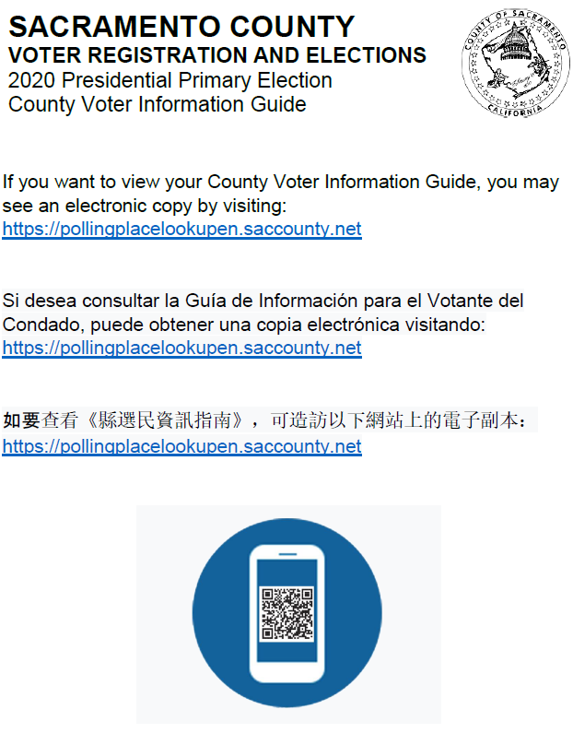

Daim Ntawv Tso Nrog Hu Ua B – Daim Duab Qhia Teeb Lub Chaw Pov Npav Ua Pivtxwv

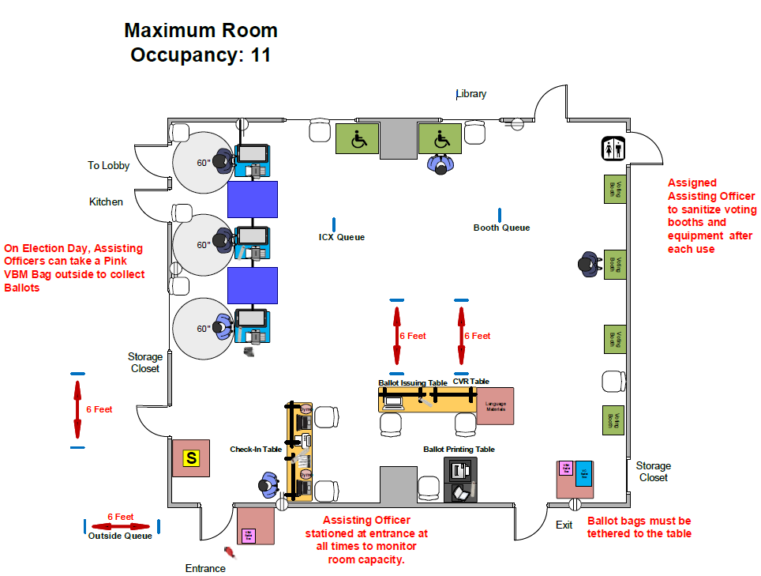

Daim Ntawv Tso Nrog Hu Ua C – Cov Kev Npaj Los Tsuag Tshuaj Tua Kabmob Tu Chaw Pov Npav
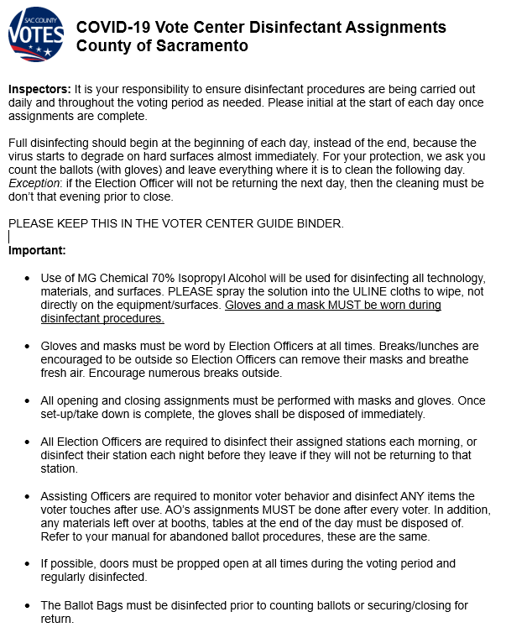

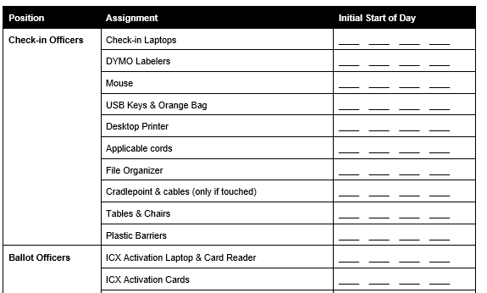

Daim Ntawv Tso Nrog Hu Ua D – Cov Paib Pivtxwv Rau Lub Chaw Pov Npav (TSEEM TSIS TAU YOG DAIM YUAV SIV)

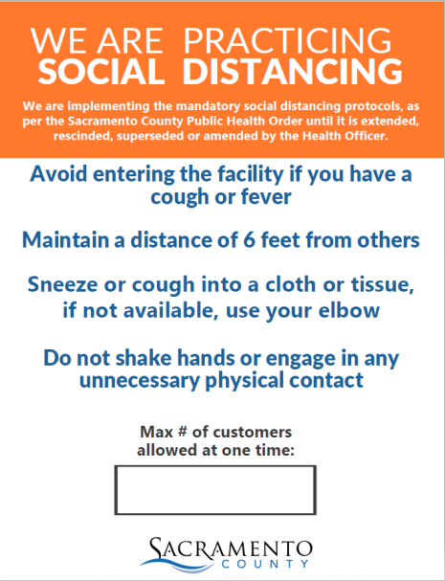
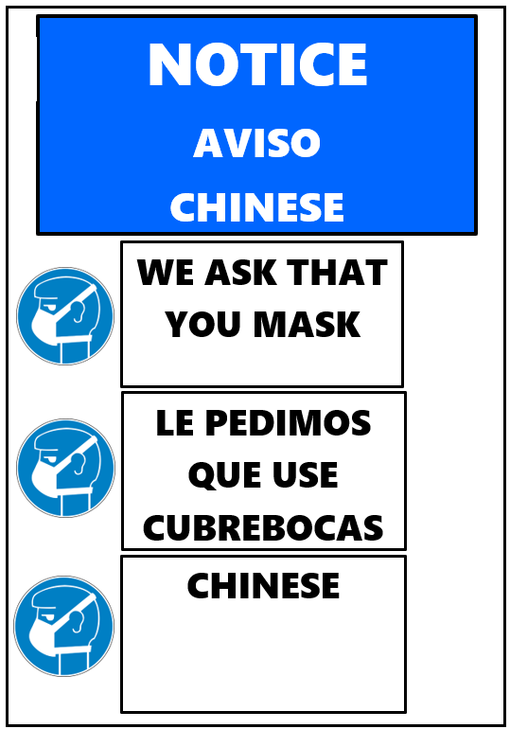

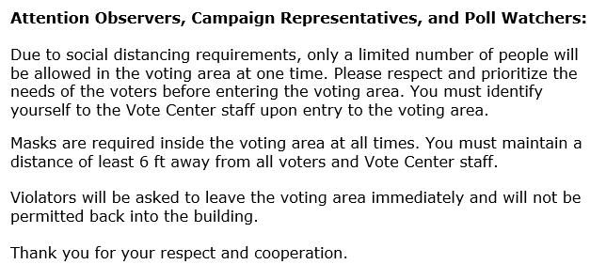

Daim Ntawv Tso Nrog Hu Ua E – Duab Qhia Qhov Kev Cob Qhia Cov Neeg Saibxyuas Kev Xaiv Tsa
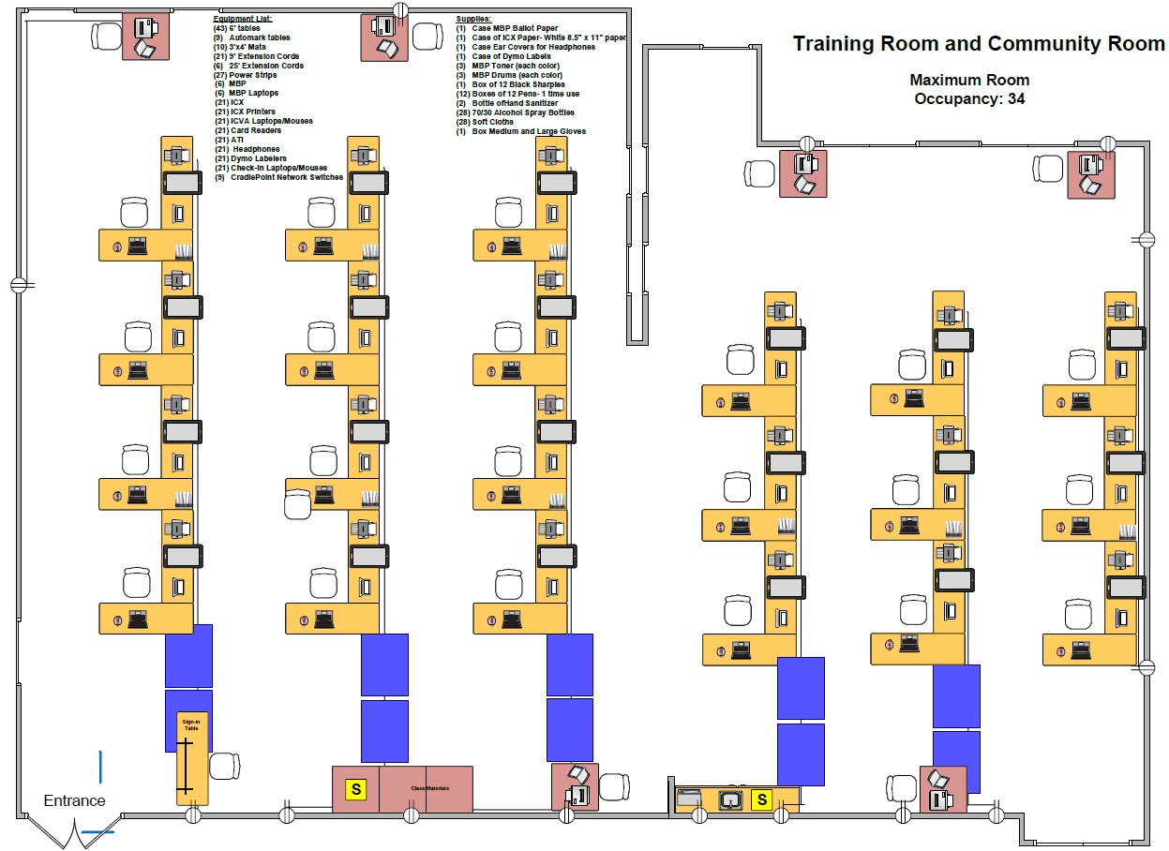

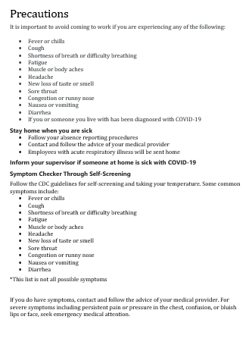
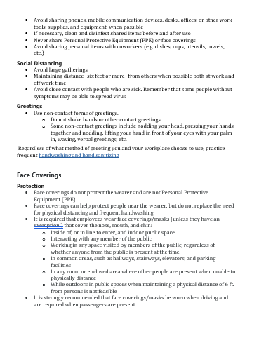
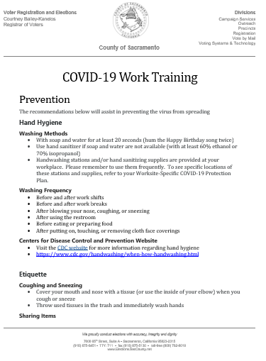
Daim Ntawv Tso Nrog Hu Ua F – Ntawv Cob Qhia COVID Pivtxwv

Daim Ntawv Tso Nrog Hu Ua G – Tswvyim Los Hais Kom Ib Qho Teebmeem Tsis Txhob Loj Ntxiv
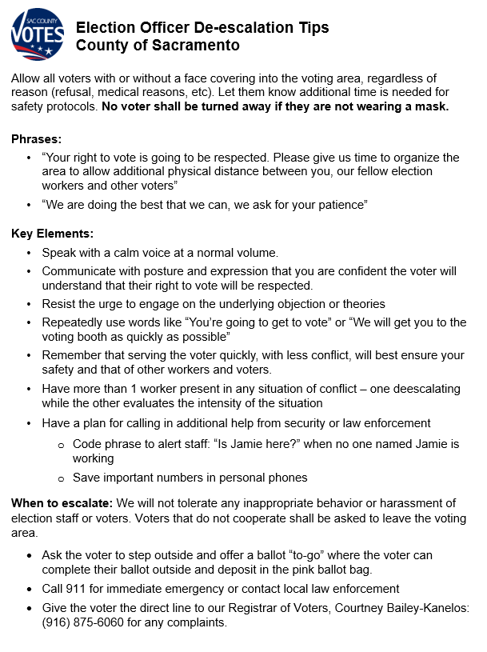

Daim Ntawv Tso Nrog Hu Ua H – VRE Txoj Kev Npaj Los Tsuag Tshuaj Tua Kabmob Tu Cov Chaw Pov Npav

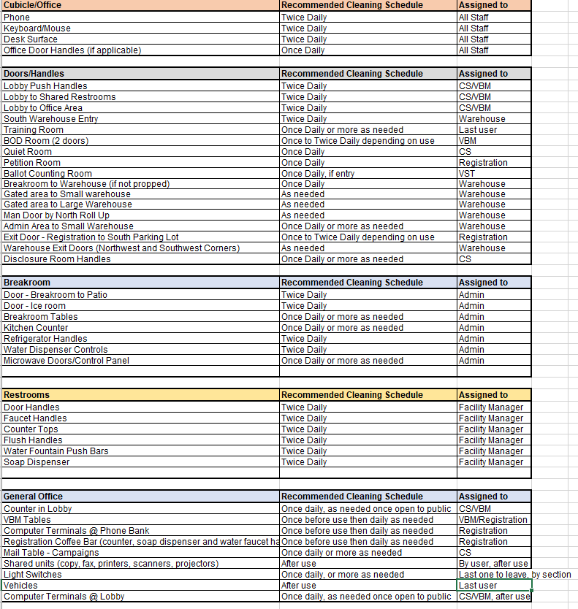

Daim Ntawv Tso Nrog Hu Ua I – Duab Qhia Txoj Kev Txheeb Npav

