COUNTY OF SACRAMENTO
VOTER REGISTRATION AND ELECTIONS

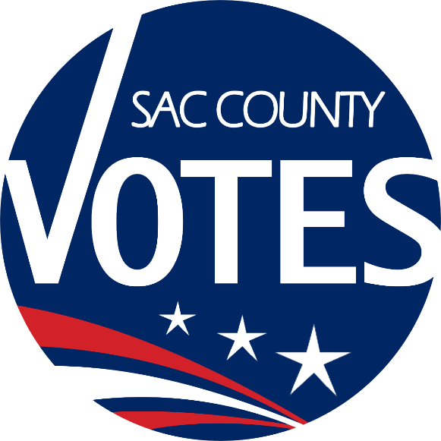

ELECTION ADMINISTRATION PLAN
COVID-19 UPDATE

County of Sacramento
Voter Registration & Elections
7000 65th Street, Suite A
Sacramento, CA 95823
(800) 762-8019
voterinfo@saccounty.net
www.elections.saccounty.net
Table of Contents
I. VOTE CENTERS 4
A. Services Available 4
B. PPE Issued to every Vote Center for Election Officers, voters, and observers. 5
C. Layout & Set-up: 5
D. Signs 7
E. Change of Location/Closure Procedure. 7
F. Vote Center/Ballot Returns. 7
II. ELECTION OFFICERS (POLL WORKERS) 8
A. Recruitment. 8
B. Training. 8
C. Traffic Directors. 8
D. Difficult Situations. 8
II. BALLOT DROP BOXES & BALLOT COLLECTION 9
III. VOTER REGISTRATION & ELECTIONS OFFICE 9
A. General Office Set-up & Disinfectant Plan. 9
B. Ballot Processing. 10
C. Observers/Media. 10
IV. OUTREACH & MESSAGING 11
A. Vote by Mail: All Vote by Mail packets will include: 11
B. Accessible Vote by Mail (AVBM). 11
C. Vote Center Procedures. 11
D. Outreach Efforts 12
E. Toolkit & Resources: 12
Attachment A – CVIG Sign Sample 13
Attachment B – Vote Center Layout Sample 14
Attachment C – Vote Center Disinfectant Procedures 15
Attachment D – Vote Center Sign Examples (NOT FINAL) 16
Attachment E – Election Officer Training Layout 17
Attachment F – COVID Training Sample 18
Attachment G – De-escalation Tips 19
Attachment H – VRE Disinfectant Plan 20
Attachment I – Ballot Processing Layout 21

Introduction:
It is important that no voter has to choose between their health and safely participating in the November 3, 2020, Presidential General Election. As the cases of coronavirus continue to surge throughout the nation, Sacramento County is actively preparing for an inclusive and safe election.
Sacramento County Voter Registration & Elections (VRE) requires thousands of civic-minded individuals to help administer an election. The overall goal of the County will be to conduct an election under the original Voter’s Choice Act, offering the same number of Vote Centers for 11 days and 4 days as were offered in the March Presidential Primary Election. However, the final number of locations will depend on facility and Election Officer availability.
Sacramento County plans to conduct this election in accordance with the Secretary of State’s Election Administration Guidance under COVID-19.
Our goal is to ensure our voters and poll workers remain safe and healthy while providing this essential service to our community. This document will detail how we plan to achieve that goal with Vote Centers, Election Officer (Poll Worker) Training, Ballot Drop Boxes, Ballot Processing, Observers/Media, and Outreach/Messaging.
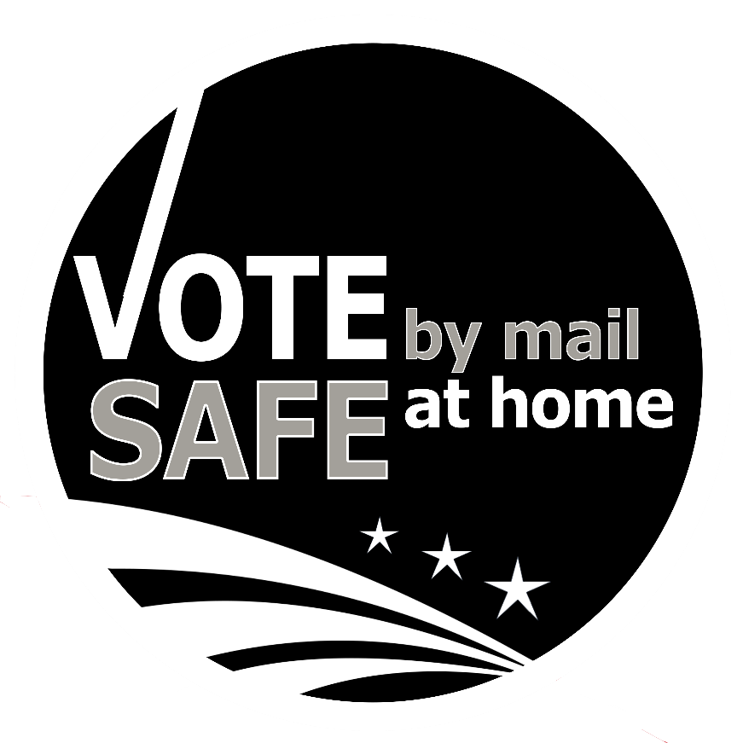

VOTE CENTERS

Services Available
    - Voting in-person or Ballot “to-go”. Services will remain the same at every Vote Center. Voters will continue to be able to vote in-person or pick-up their ballot at any Vote Center location. In addition, a voter’s designee with a completed Ballot Pick-up Authorization form can pick-up a ballot for the voter at our office at 7000 65th Street, Ste A, or at any open Vote Center location to bring to the voter to complete. We advise these ballots be dropped off at any Ballot Drop Box location or Vote Center.
    - Accessibility. Curbside Voting and a minimum of three Accessible Ballot Marking Devices (Dominion’s ImageCast X devices, called “ICX”) are available for use at every Vote Center location.
    - Voter Assistance.
      - Guide Tethers are available to assist in leading voters who are blind or have low vision to a voting booth, ICX machine, a table, or on where to stand while waiting.
      - Voters with disabilities should let an Election Officer know their specific needs upon entry to ensure adequate assistance is provided.
      - Up to two people can come with a voter to assist them. Masks will be available for all, including children.
      - If a voter cannot or will not wear a mask, the Election Officer shall stay 6 feet away from the voter at all times. If a voter cannot or will not wear a mask, but requires assistance closer than 6 ft, the Election Officer will be required to wear a face mask, with a Face Shield or portable barrier for added protection.
    - Hard/Physical Materials.
      - Hard copies of State Voter Information Guides and measure information will be available on the Language Materials Table, however, voters are encouraged to access their County Voter Information Guide or State Voter Information Guide on their smartphones using the QR code provided. Voters are encouraged to mark their sample ballot included in their County Information Guide prior to visiting the Vote Center to help limit their time in the voting area. (See Attachment A for example)
      - Secrecy Sleeves will not be available. For extra privacy voters will be directed to fold their ballot in half after they make their choices.
      - Vote Center Experience Survey slips will not be available this election. Instead, call-in cards will be provided for voter questions, concerns, feedback, or to check the status of their ballot.
      - While VRE will be providing a hard copy of the translated composite ballots, referred to as our Ballot Translation Guide, copies may also be printed by the Check-in Officer upon request.

PPE Issued to every Vote Center for Election Officers, voters, and observers:
    - Individually wrapped masks, including child sizes
      - Voters will be strongly encouraged to wear masks, but voters shall not be turned away if not wearing a mask
      - A mask will be offered to every voter without one
      - Script will be provided to Election Officers on how to handle these situations (See (II)(D) Difficult Situations)
    - Disposable deli-style gloves available at each Election Officer station
      - To be disposed of after every voter or interaction
      - If no gloves are available, sanitize hands after every voter
    - One-time use pens
    - Hand Sanitizer, located throughout the Vote Center and at all Election Officer stations, to sanitize upon entrance
    - Face Shields, available upon request, will be offered as an alternative to voters who refuse to wear a mask
    - Plastic Barriers
    - MG Chemicals (70% Isopropyl Alcohol) will be used to disinfect:
      - ICX machines, after every use
      - ICX Activation Cards
      - Voting booths, after every use
      - Election Officer laptops, printers, DYMO Labelers, USB units, including the Mobile Ballot Printer
      - Ballot Bags, after touching
      - Plastic Barriers: only if touched, sneezed on, coughed on, or after a voter without a mask
      - Guide Tethers
      - Tables & Chairs, after every use
      - Stanchions
Material Safety Data Sheets (MSDS) with information on how to treat staff, should they have unsafe contact with a chemical irritant will be available at all Vote Centers .

Layout & Set-up:
    - A sign indicating the maximum number of people that will be allowed in the voting area at one time will be posted at every Vote Center. This includes voters, observers, friends/family assisting the voter, and Election Officers. The formula used to determine this number is one person per 100 square feet. Election Officers, known as Assisting Officers, will be standing outside every Vote Center with the responsibility of:
      - Monitoring maximum occupancy levels (walkie-talkies will be provided to larger locations)
      - Accepting Vote by Mail ballots dropped off by voters. Voters just dropping off their voted ballot will not be allowed in the voting area, unless they require additional assistance. Glue sticks will be available at all Vote Centers to seal ballot envelopes
      - Offering individually wrapped masks to every voter without one, including offering masks to children or other people that may be assisting the voter
      - Monitoring Observers. Poll Watchers, Monitors, Campaign Representatives and Media will not be allowed inside the voting area without a mask. No exceptions
      - Vote Centers without a protective overhang outside will be issued waterproof canopies
    - For Vote Centers with more than one door, a clearly marked “Entrance” and “Exit” sign will be posted. For Vote Centers with only one entrance/exit, the Assisting Officer will monitor congestion at the doorway
    - Each Vote Center will have a diagram of set-up that includes the maximum occupancy numbers and placement of where people should stand to practice social distancing (See Attachment B for an example)
    - Blue painters’ tape will indicate the location where voters shall stand to check-in; or wait for their ballot, ICX activation card, voting booth, or to use the ICX unit. These markings will be set-up prior to voting by the Election Officers (outside) and our Chaser team doing delivery of the equipment (inside)
    - Stanchions will be provided to larger Vote Center locations to assist with queuing inside and outside the Vote Center
    - Plastic barriers will be set-up at the Check-in station, Ballot Printing station, and CVR station. Additional barriers will be issued to each location to place or use as needed
    - 20 extra chairs will be requested for use from the facility or issued by VRE if the facility cannot provide them. These shall be reserved for voters waiting in line
    - A designated “Sanitation Station” (noted in Attachment A as “S”) will be set-up with hand sanitizer and tissue
    - Each station will be provided garbage bags for trash, used masks, used gloves, used pens, etc.
    - One-time use only pens will be issued to the voter by the Ballot Officer or CVR Officer. Pens will be available at the Check-in Officer station, along with a scratch pad, to help with communication barriers.
    - Disinfectant procedures will be included in every Voter Center Guide Binder (See Attachment C for an example). Election Officers will be required to disinfect their own stations every morning, and at night if not returning to that station the next day. Assisting Officers will be responsible for disinfecting and monitoring the booths and ICX machines
    - Deep cleaning services, including cleaning of all hard surfaces, floors, touch points, and running of HEPA filters, will be offered to every Vote Center

  - Signs – Attachment D Samples
    - “We Ask That You Mask”, trilingual, inside and outside every Vote Center
    - Entrance/Exit Signs, trilingual
    - Observer/Poll Watcher sign, English only
    - Sacramento County Maximum Occupancy Signs, already used by Sacramento County businesses, trilingual
    - “Line Up Here” signs
    - Numbers, to be placed on voting booths
    - Sanitation Station Sign

  - Change of Location/Closure Procedure. There is a chance that after the publication of locations in the County Voter Information Guide, a Vote Center may not be able to open, due to facility issues or lack of Election Officers. If this happens, Sacramento County will do the following:
    - Place a sandwich board with signage at the closed location with a list and map of the nearest Vote Center locations
    - Assign a team of two people to stand outside the closed location with a designated pink Vote by Mail bag to collect ballots from people dropping off their ballot
    - Update our website, voter look-up tool, SacVote app, and issue a media release
    - Ensure all phone bank representatives in VRE are aware of the change

  - Vote Center/Ballot Returns. Vote Center staff and designated Ballot Transporters are to wear gloves when transporting materials. Staff at VRE will wear a new set of gloves to receive any materials or ballots from each location or Ballot Transporter. Ballot Transporters using a County or rental vehicle will be required to disinfect the vehicle prior to their shift ending.

ELECTION OFFICERS (POLL WORKERS)
  - Recruitment. In July of 2020, availability cards were sent to over 10,000 Election Officers that Sacramento County has on file. Election Officers were instructed to complete and return the card, postage paid, or go online to confirm their availability for the November 3, 2020, Election. In addition, a comment space was provided for Election Officers to express their concerns regarding this election. Most comments expressed concern about PPE being provided. To the best of our ability, we will work to have trained “standby” Election Officers that can be deployed to assist with busy locations or step-in as a replacement.

  - Training. Most of the training content will be available through our Election Officer EasyVote portal which will contain PowerPoint slides and accompanying audio and videos. A minimal amount of in-person training of Election Officers will still be required. Iin person training sessions will take place at the main VRE office at 7000 65th Street. Training will be “hands-on” with the check-in laptops, Mobile Ballot Printers, and ICX Machines. Each attendee will have a separate station with dedicated equipment. Attendance will be limited to maximum room capacity of 1 person per 100 square feet. Attachment E provides the layout for our “hands-on” training sessions. All Election Officers will be required to wear masks throughout training and at the Vote Centers.

In addition, Election Officers will receive mandatory COVID-19 training developed by the Sacramento County Department of Personnel Services (Attachment F). Inspectors will be required to go over the disinfectant procedures and site-specific safety instructions with their assigned Election Officers on site at the Vote Centers. Election Officers will attest by signature that they received the training.

  - Traffic Directors. Traffic Directors will be assigned to every Vote Center. These Assisting Officers will be stationed outside the Vote Center with the pink ballot bag to accept ballots from voters dropping off their voted ballots. In addition, these Assisting Officers will be monitoring how many people are inside the voting area at one time, utilizing walkie talkies as needed, and offering masks and face shields to anyone waiting to enter. These Assisting Officers will be wearing pink lanyards with a plastic badge identifying them as Election Officers. Assisting Officers will be trained to check for signatures on the return envelope and will have one-time use pens and glue sticks available for voters. Gloves and hand sanitizer will be available. Gloves must be worn by the Assisting Officer when handling ballots or exchanging any materials.

  - Difficult Situations. Presidential General Elections are always challenging and heated. During a pandemic, this will be compounded and altercations regarding mask usage, election security, and long lines are expected. In addition to voter messaging and setting forth expectations of long lines on Election Day, we are working to provide our Election Officers with tips to stay safe and diffuse any situations. Sacramento County will be incorporating the Secretary of State’s Guidance into procedures located in the Vote Center Guide Binder on how to de-escalate situations (Attachment G).

In addition, all Vote Center locations will be provided to County Sheriff and City Police Departments in case such a situation may arise. Police or Sheriff would only be dispatched if there was a threat or altercation that could not be handled by the Election Officers.

- BALLOT DROP BOXES & BALLOT COLLECTION. Sacramento County has reached out to grocery and retail store chains to host drop boxes within the County. Raley’s/Bel-Air agreed to host Official Ballot Drop Boxes and VRE will be utilizing all locations in Sacramento County. VRE will continue to work with the Sacramento Public Libraries and our City Offices to host Ballot Drop Boxes. Our goal is to have 58 Ballot Drop Box locations open beginning October 5. 24-hour exterior boxes will be provided at VRE and at Citrus Heights City Hall.

Confirmed locations will be published on the VRE website mid-September, and will be included in the County Voter Information Guide, and in voter’s Vote by Mail packet.
As controversy surrounds the United States Postal Service, VRE continues to be in communication with our local postal representatives. Regardless of the situation as November approaches, the concerns have already taken root throughout the nation. VRE is preparing for an increase number of ballots being dropped off by issuing additional boxes to all of our locations. Teams will be set-up to regularly check the boxes and pick-up ballots in accordance with the Emergency Ballot Pick-up standards.
We invite any community partners to assist VRE with ballot collection events, especially if there is an increase in need and VRE cannot accommodate the volume. Community partners would be deputized to accept ballots on VRE’s behalf, just as all Ballot Drop Box locations have deputized staff. Chain of Custody forms and procedures are in place for community volunteers to assist with any events. Approval of any ballot collection event is at the discretion of the Registrar of Voters and will be done in accordance with election law and procedures.

VOTER REGISTRATION & ELECTIONS OFFICE
  - General Office Set-up & Disinfectant Plan. Through April and May, VRE has worked to create a safe working environment at 7000 65th Street. This includes:
    - Portable plastic barriers at the front counter while awaiting a permanent installation of a plexiglass barrier
    - Plastic barriers between cubicles, including custom barriers for the phone bank
    - Markings on the floor where customers should stand to ensure social distancing
    - A designated entrance and exit
    - Stanchions for queuing customers
    - Mandatory mask policy for staff. Only exception is when staff is at their desk and more than 6 feet away from someone. Staff is encouraged to take breaks every hour to get fresh air
    - Signage of maximum occupancies in each room/area (1 person for every 100 square feet)
    - Signage requesting customers to wear masks. Masks will be offered to all customers without masks.
      - For customers without masks, they must remain behind a plastic barrier, stay 6 feet away, or wear a face shield
    - CDC COVID Posters
    - Take-a-number system deployed in the lobby
    - Hand Sanitizer stationed throughout the office
    - Disinfectant Plan (Attachment H)
      - A Material Safety Data Sheet (MSDS) is required under US OSHA Hazard Communication Standard and all new chemicals brought into the department will be evaluated and added to the MSDS.
In addition, staff is encouraged to stay home if they are not feeling well. Temperature checking procedures are currently being evaluated. The Registrar of Voters is actively working with Sacramento County’s Director of Public Health for all election related activities.

  - Ballot Processing. Now that ballot processing can begin 29 days before Election Day, VRE will evaluate incoming volume to determine the appropriate time to start processing returned ballots. Attachment I shows the layout for processing to continue safely. Maximum Occupancy will be monitored and enforced at all times, including the Ballot Counting Room. Virtual and live-streaming options to monitor election activities are currently being reviewed. Portable plastic barriers will be made available, along with PPE for all customers and staff. Canvass activities are still being determined.

  - Observers/Media. At all Vote Centers, Observers and Media will be required to wear a mask at all times. At VRE, Observers who plan to stay in one area longer than 15 minutes will be required to wear a mask AND a face shield. Social distancing will be enforced. VRE is currently evaluating ways to ensure social distancing while also maintaining transparency, such as virtual tours, live streaming of Election Night counting and returns, and projecting procedures on a wall or larger screen. In addition, Observers and Media must make a prior appointment, walk-ins will not be accommodated. There will be identified areas throughout the office where Observers and Media will be asked to stand.

OUTREACH & MESSAGING

Vote by Mail: All Vote by Mail packets will include:
    - Voter’s official ballot
    - Pink Return Envelope
    - “I Voted” sticker insert
    - Vote Safe Insert (NEW) Attachment J
Voters will be encouraged to return their ballot early, by mail or Ballot Drop Box. VRE will continue to monitor the situation with the United States Postal Service. Misinformation regarding Vote by Mail, and the checks and balances in place for Vote by Mail, will continue to be a main talking point with any VRE outreach efforts.

  - Accessible Vote by Mail (AVBM). This option will be made available to all voters starting 29 days before Election Day. There will not be an active campaign or outreach effort, but staff will be providing this option to voters over the phone or via email, even if they are not military/overseas or have a disability. VRE plans to utilize this option as the election draws near, after October 27, when it is too late to mail ballots to voters. The situation with the USPS may change the messaging around this option.

Verbiage has been added to the AVBM system so voters can select COVID-19 as an option for using the system. Please see the demo site for exact verbiage.

  - Vote Center Procedures. Notices will be mailed to every voter and placed on the VRE website informing voters of expectations for in-person voting. Voters will be encouraged to:
    - Wear a clean face covering
    - Bring comfortable shoes for waiting in line
    - Bring their County Voter Information Guide to help with communication during check-in and complete their Sample Ballot to limit their time in the voting area
    - Let the Vote Center staff know if they have a disability and need additional assistance
VRE is working with the Sacramento Kings and other community partners to emphasize the importance of voting early and avoiding lines on Election Day. With social distancing requirements in place and a limited number of voters allowed in the voting area, lines are to be expected.

  - Outreach Efforts. While many events had to be cancelled due to COVID-19, such as our High School Mock Elections, the VRE Outreach team continues to find creative ways in dispersing election messaging throughout the community. Efforts include:
    - Distributing materials to grocery stores, including ethnic grocery stores in our historically low turnout areas
    - Distributing materials to food distribution and COVID testing sites
    - Distributing materials to schools
    - Distributing materials to organizations that are still providing services to customers
    - Locating virtual community events where we can talk about the upcoming election, even for two minutes
    - Providing articles and information to local print and e-newsletters
    - Providing Webinars and distributing materials to jails, hospitals, care homes, and assisted living facilities
    - Coordinating a Joint County Outreach Campaign in our shared media market with El Dorado, Nevada, Placer, San Joaquin, Stanislaus, Sutter, Yolo, and Yuba. 30 second radio messages, digital advertising, and media events are being planned for September and October. A “kick-off” event is slated for September 17 at the West Sacramento Post Office. Details will be forthcoming
    - Sacramento will continue to use the same media partners listed in Appendix C of the original Election Administration Plan, with the addition of a partnership with the Slavic Chamber of Commerce to assist with distributing printed materials, sharing information on social media, and creating partnerships with community and faith leaders
    - Sacramento Kings will be working on advertisements with Regional Transit and offering free rides on Election Day

Toolkit & Resources:
    - Voter Registration & Elections November General Toolkit
    - Voting by Mail in Sacramento County

Attachment A – CVIG Sign Sample
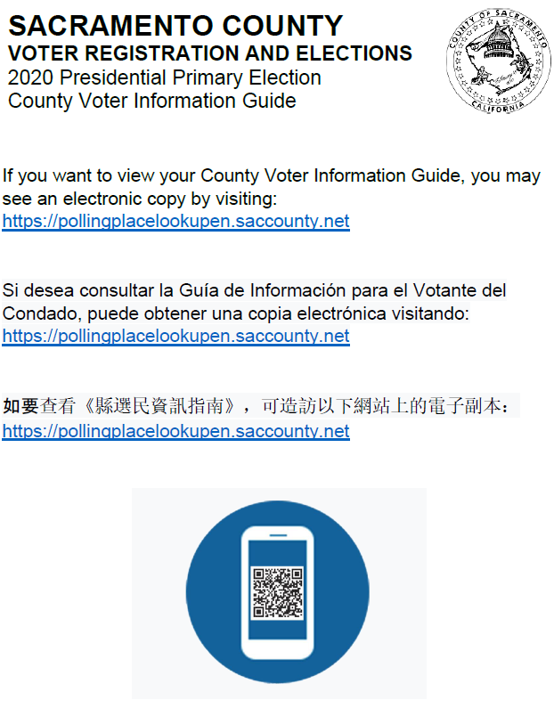

Attachment B – Vote Center Layout Sample

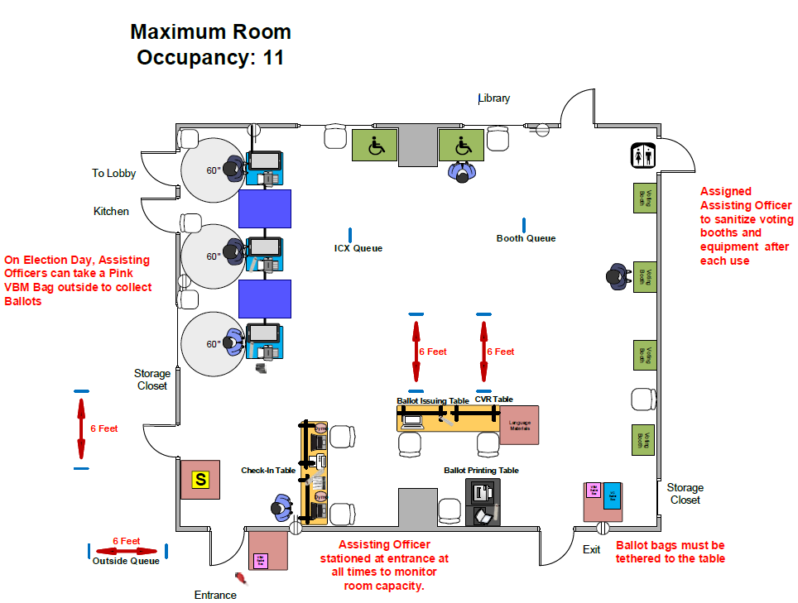

Attachment C – Vote Center Disinfectant Procedures
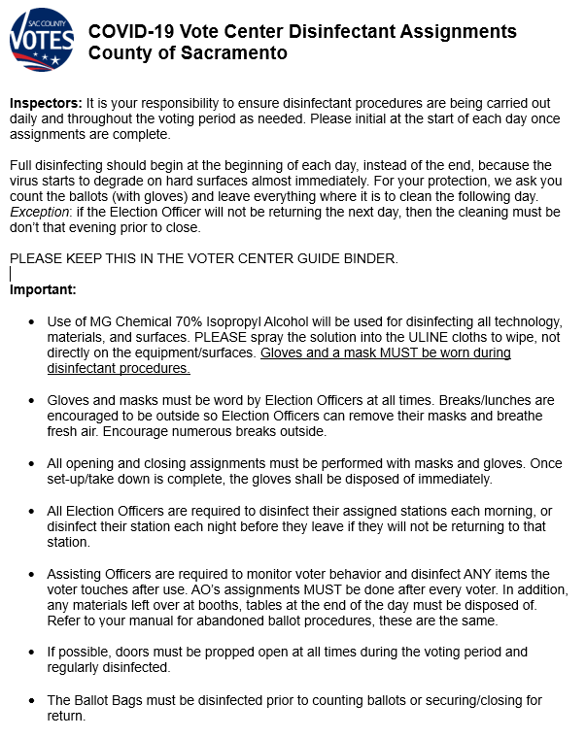

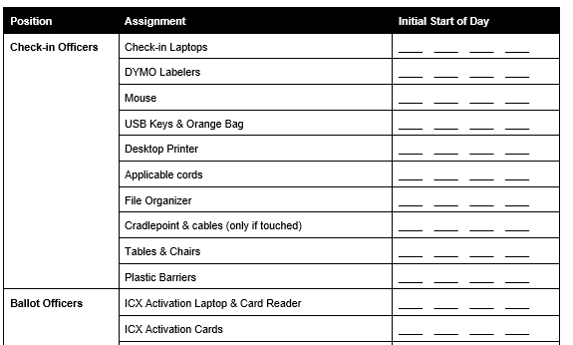

Attachment D – Vote Center Sign Examples (NOT FINAL)

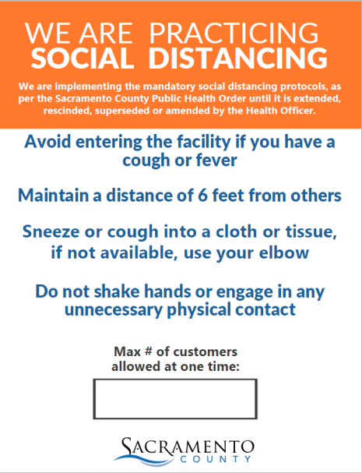
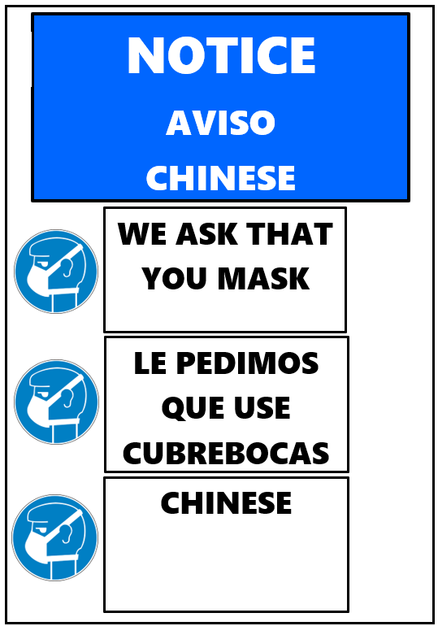

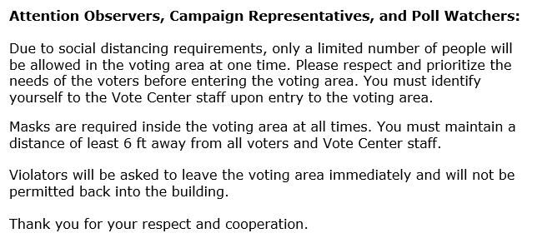

Attachment E – Election Officer Training Layout
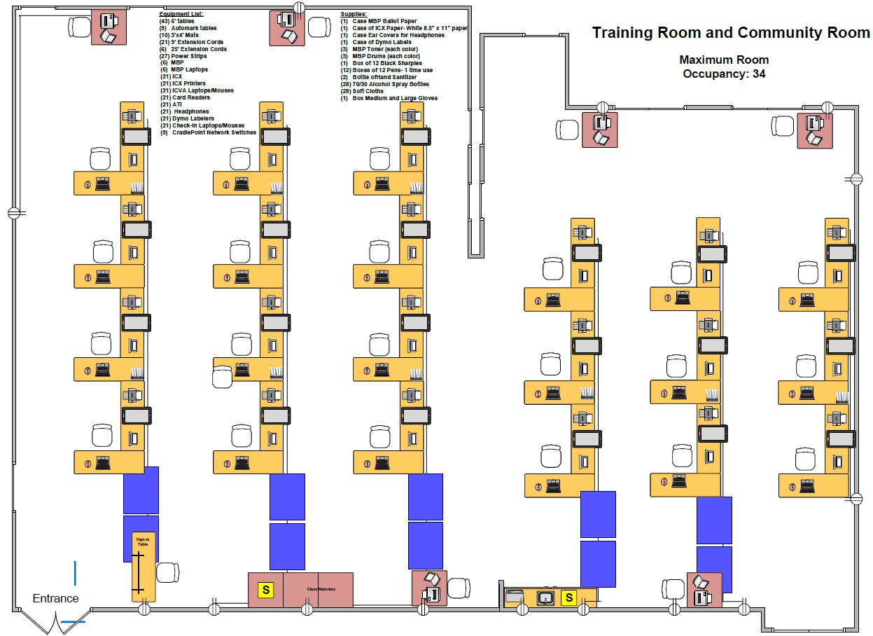

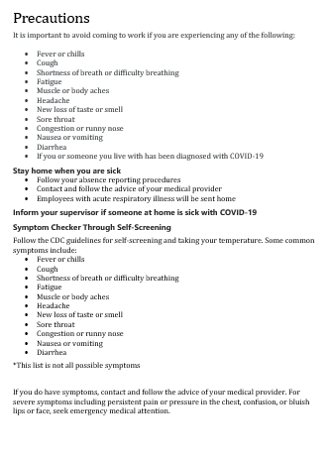
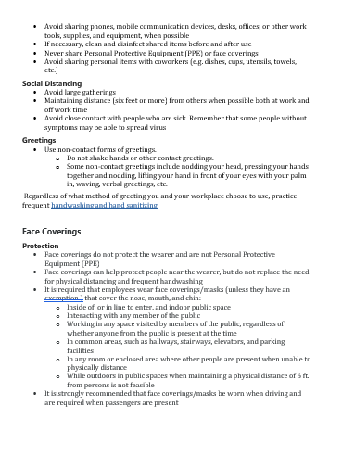
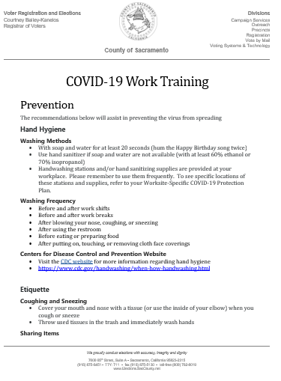
Attachment F – COVID Training Sample

Attachment G – De-escalation Tips
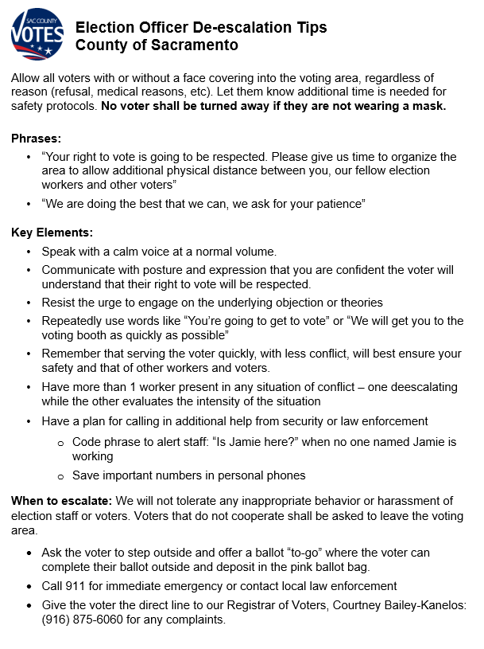

Attachment H – VRE Disinfectant Plan

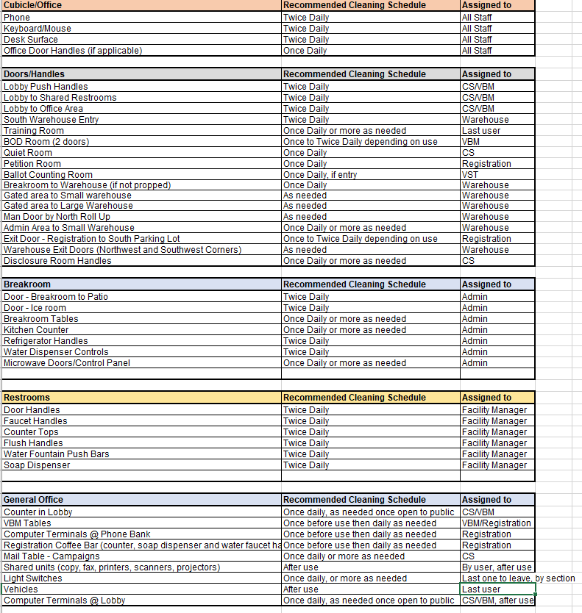

Attachment I – Ballot Processing Layout

