FINAL
4-DAY VOTE CENTER LOCATION MAP
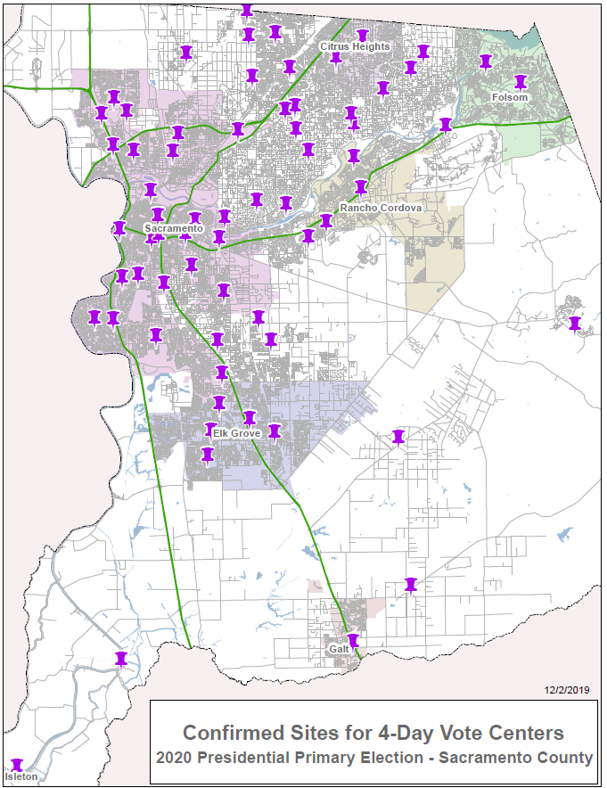

11-DAY VOTE CENTER LOCATION MAP
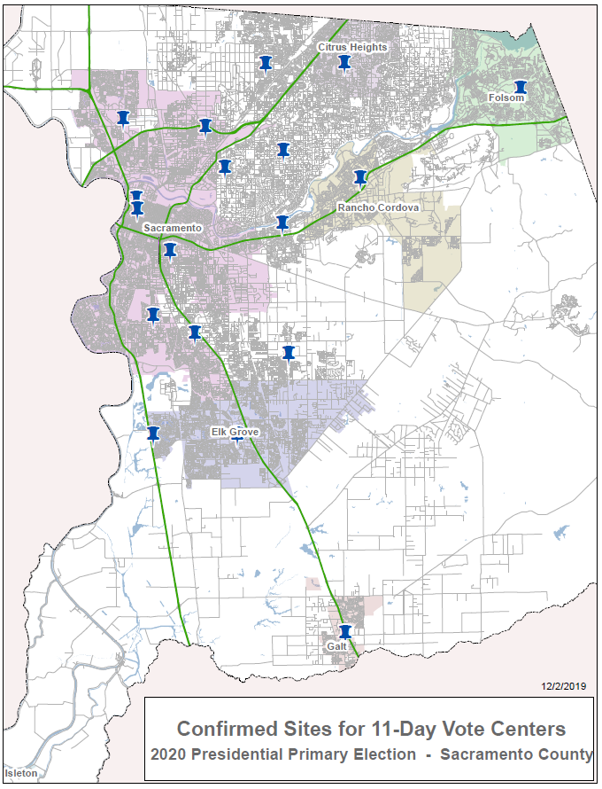

DROP BOX SITES LOCATION MAP
Th