4-DAY VOTE CENTER LOCATION MAP
Current as of November 4, 2019
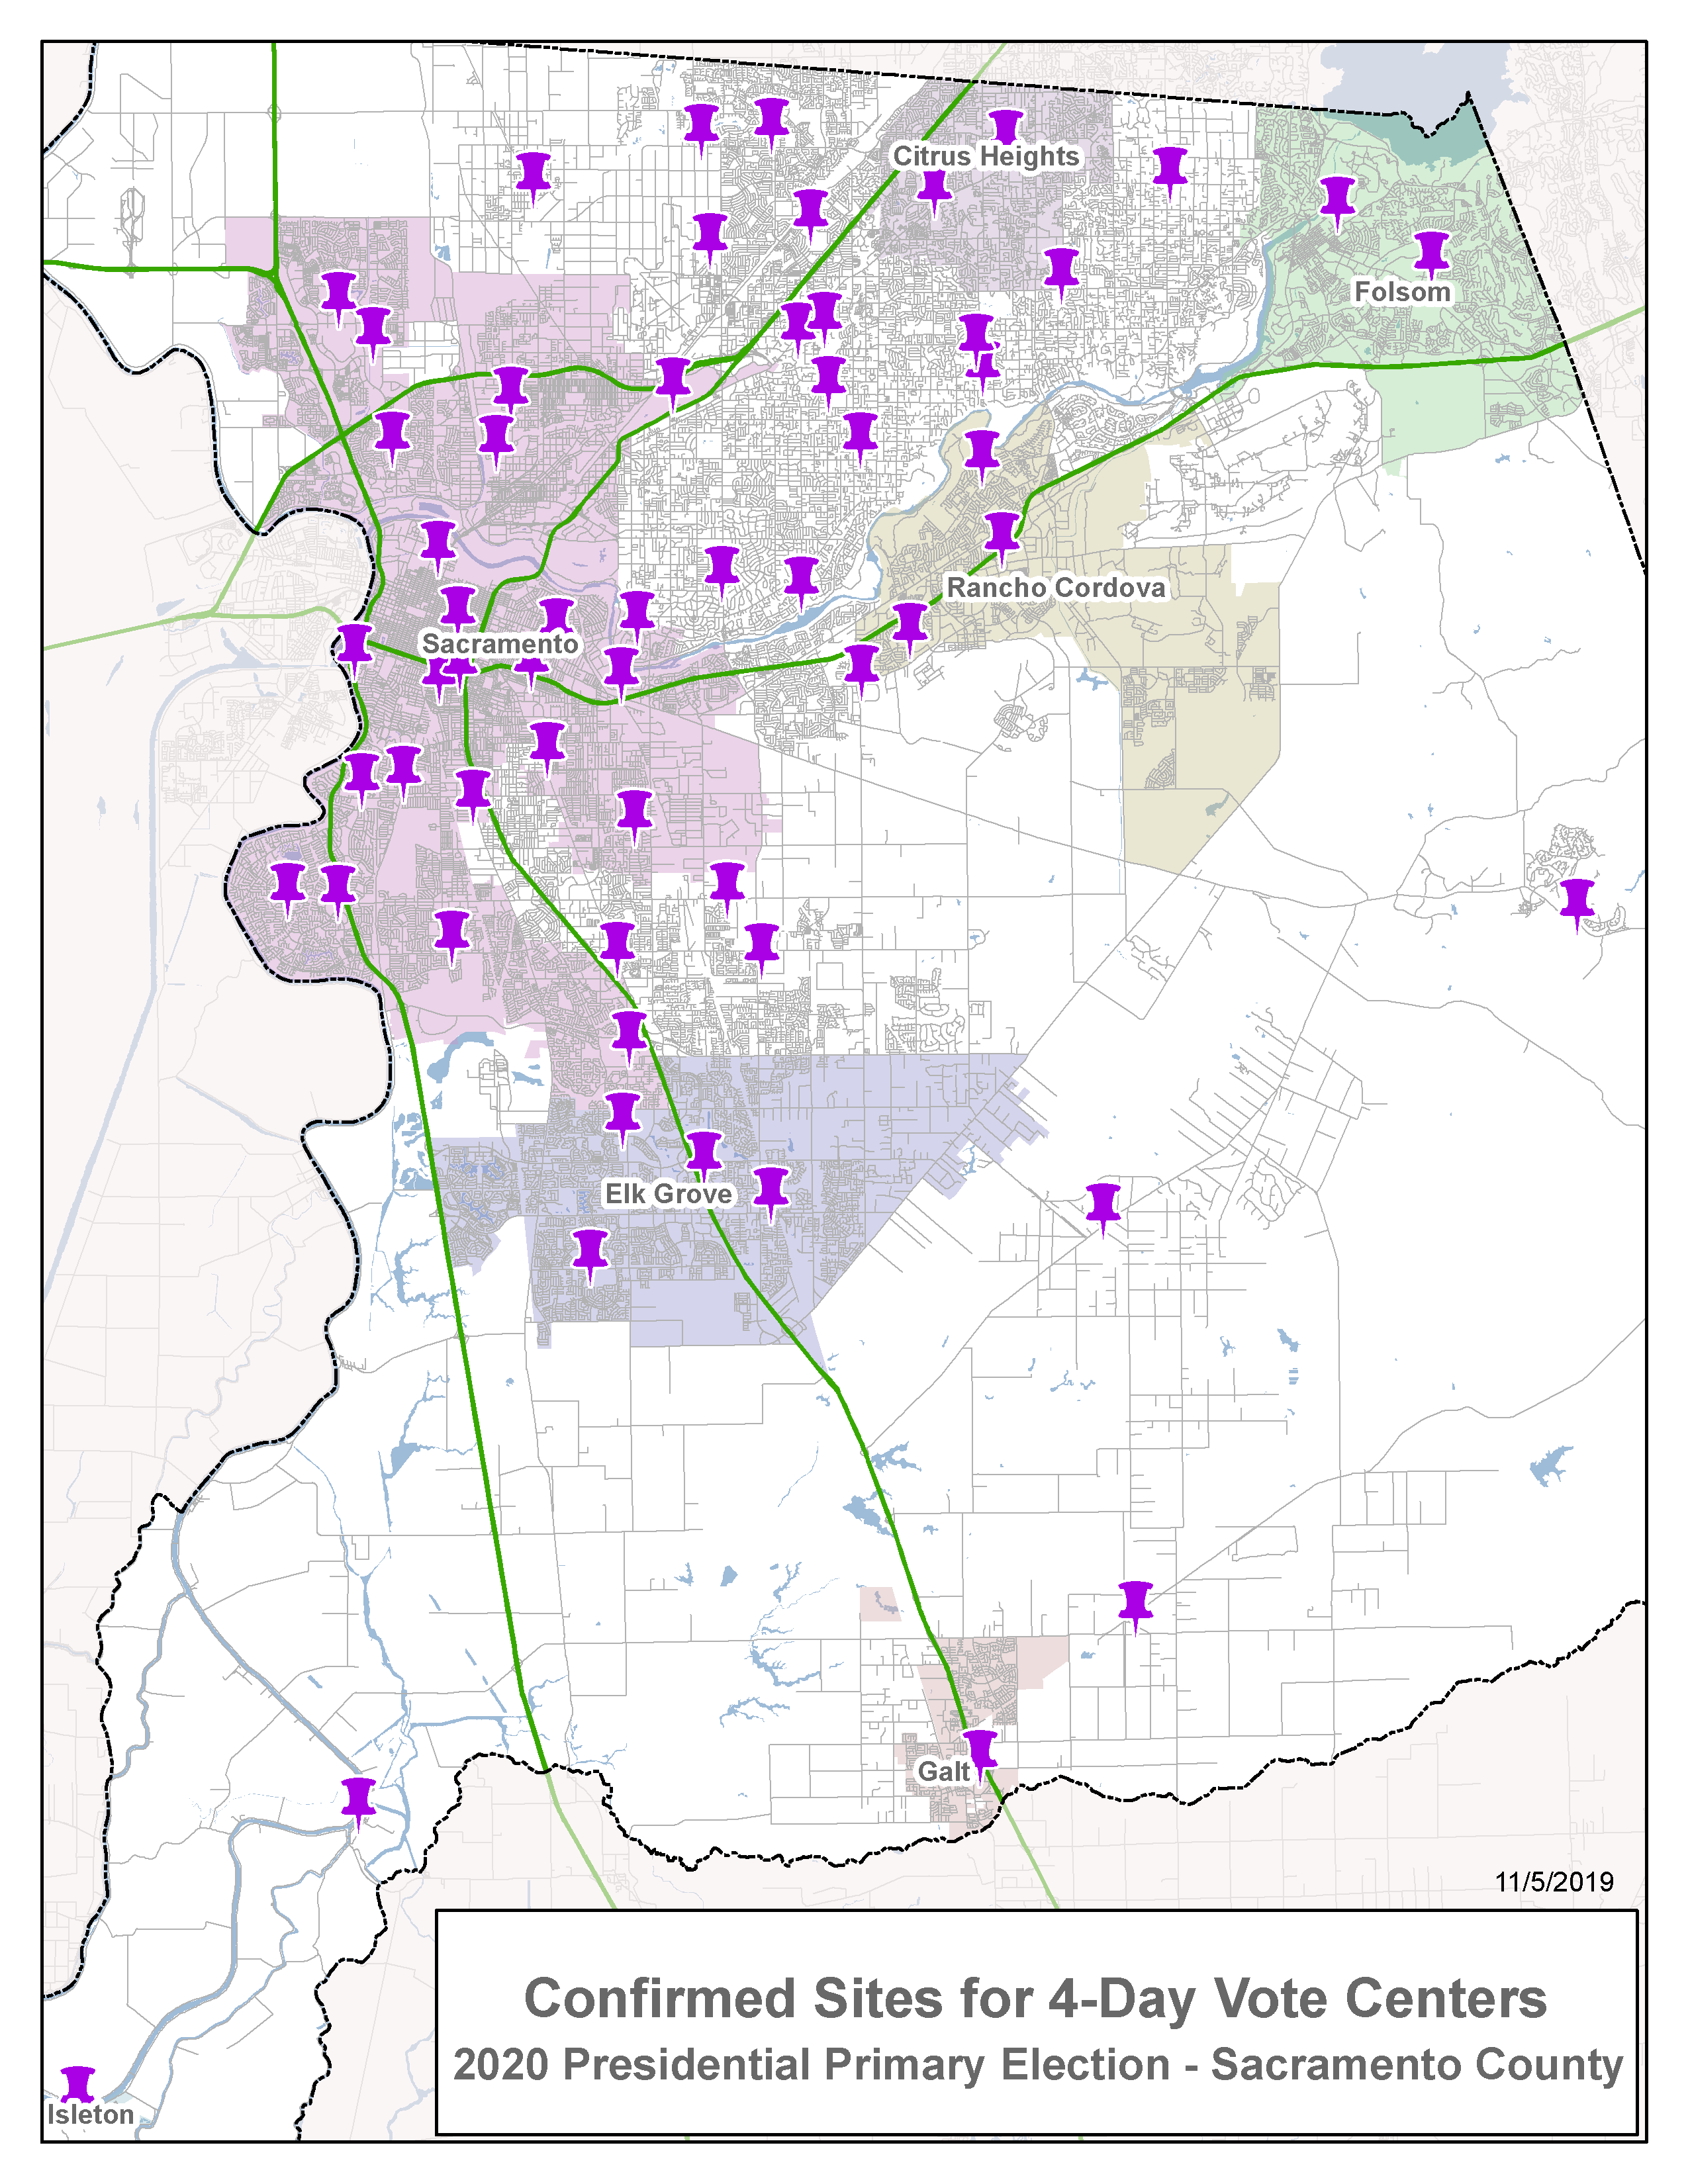
11-DAY VOTE CENTER LOCATION MAP
Current as of November 4, 2019
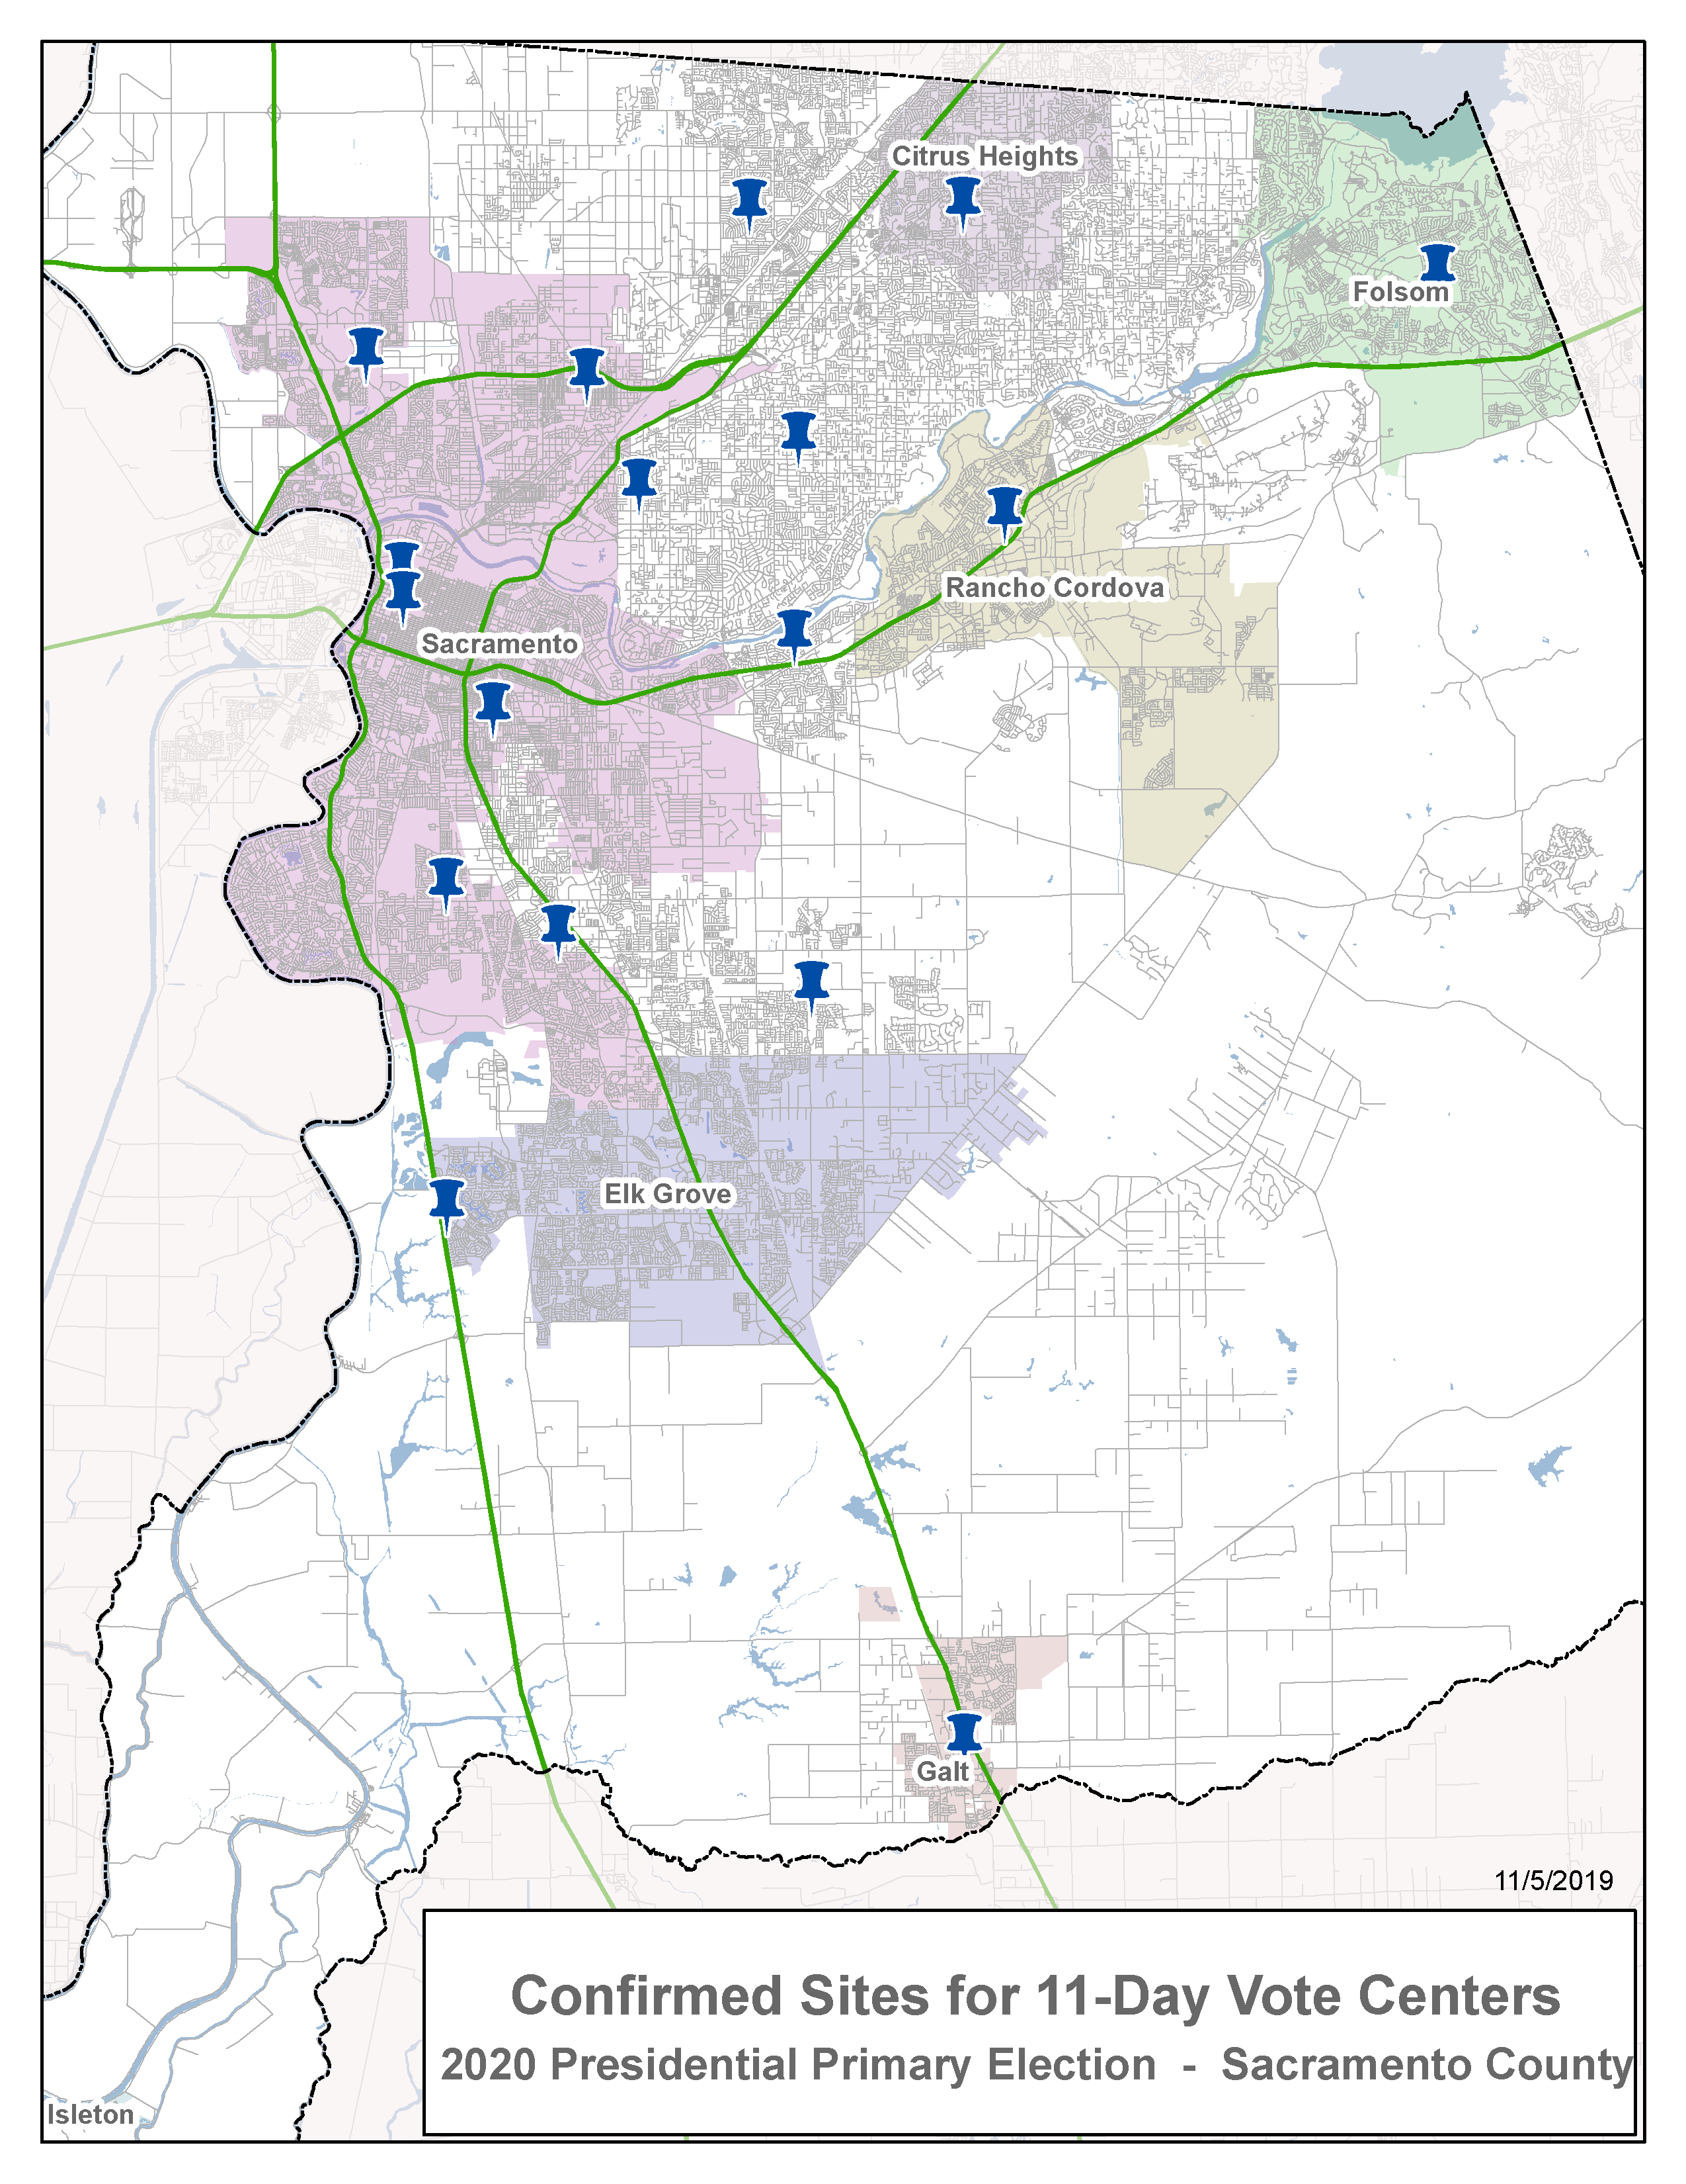
DROP BOX SITES LOCATION MAP
Current as of November 4, 2019
