APPENDIX B: DIRECT VOTER CONTACT

Below are the direct postcards mailed to voters for the November 6, 2018 General Election.

Direct Voter Contact Postcard 1 – November 6, 2018 General Election
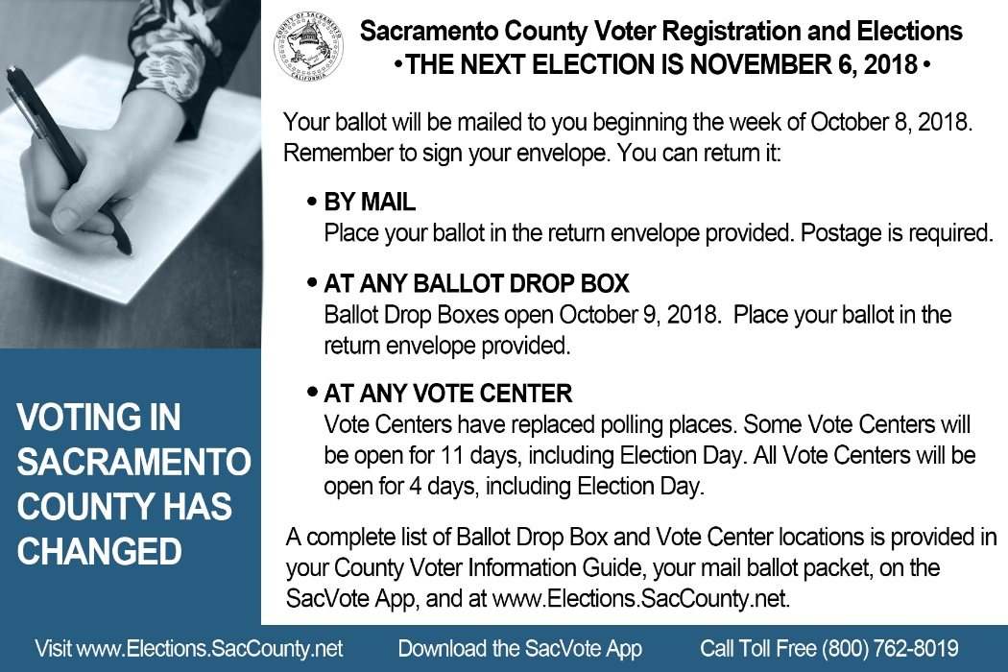

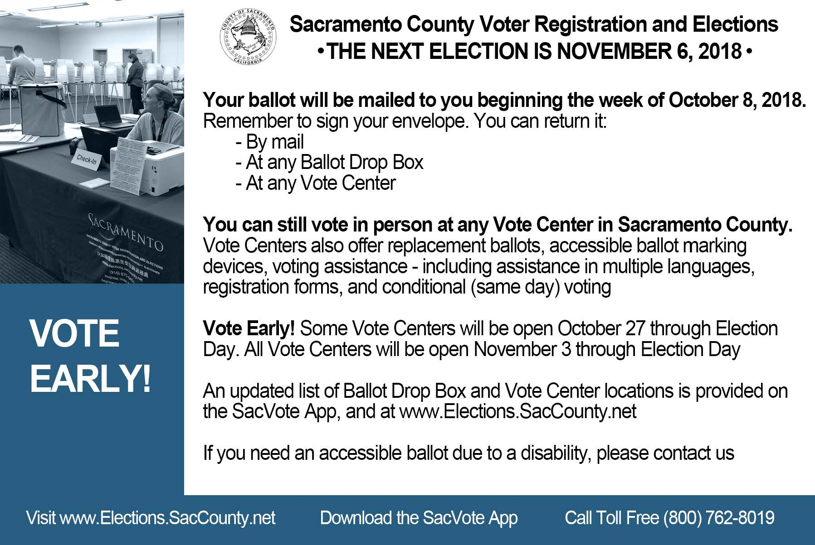
Direct Voter Contact Postcard 2 – November 6, 2018 General Election

